Japan International Cooperation Agency (JICA)
Sustainable Natural Resource Management Project (SNRM)

CASE STUDY

“BOUNDARY PLANTING – TREES OF HIDDEN HOPE FOR FOREST MANAGEEMENT AND PROTECTION”

Hoang Dinh Quoc
Provincial Coordinator of Lai Chau Province

July, 2020

This case study was prepared as a part of the Sustainable Natural Resource Management Project (SNRM) funded by the Japan International Cooperation Agency (JICA) and executed by the Ministry of Agriculture and Rural Development of Viet Nam from 2015 to 2020.

The views expressed in this case study are those of the authors and do not necessarily reflect the view of SNRM or JICA.

JICA/SNRM encourages reproduction and dissemination of material in this case study. Non-commercial uses will be authorized free of charge upon request. Reproduction for commercial purposes, please contact JICA/SNRM for a prior and specific agreement.

All queries should be addressed to:

Officer in Charge of Forestry Projects/Programmes
JICA Viet Nam Office
11F CornerStone Building, 16 Phan Chu Trinh, Hoan Kiem, Ha Noi, Viet Nam
Tel: +84-4-3831-5005
Fax: + 84-4-3831-5009

Table of Contents
I. INTRODUCTION 4
II. SUPPORT FROM SNRM PROJECT 5
1. VILLAGE MEETINGS 5
2. DOCUMENT DESIGN 5
3. COLLECTION OF KNOWLEDGE FROM LOCAL AUTHORITY 6
4. TECHNICAL TRAINING 7
5. PROVISION OF SEEDLINGS AND PRODUCTIOIN INPUT 7
6. MONITORING TREE DEVELOPMENT 8
III. ACHIEVEMENT 8
1. MANAGEMENT LIVESTOCK DAMAGE 8
2. MANAGEMENT OF DISEASES AND NATURAL DEATH 9
3. MANAGEMENT OF DROUGHT 9
4. MANAGEMENT OF TREE DEVELOPMENT 10
5. POTENTIAL INCOME 10
6. IMPACT 11
IV. LESSONS LEARNT 11
V. RECOMMENDATIONS 12

INTRODUCTION
According to the Socio-economic survey by the SNRM Project in 2016, tea is a main source of income for Phuc Khoa farmers. There is much potential for farmers in Phuc Khoa commune to improve their income from tea production. Therefore, the need of expanding tea production area has been rapidly increasing that possibly leads to illegal encroachment to forests and forestry land. The Sustainable Natural Resource Management Project (SNRM), mainly and directly supporting sustainable forest management in Lai Chau since 2016, has introduced an activity, so-called establishment of boundary system, to monitor and limit this forest and forestry land encroachment problem.
The boundary planting system introduced by the SNRM Project is referred to as a living fence or barrier planting which includes planting trees along the actual boundary of agricultural field and forest land. Generally, boundary trees planting are essentially established for land delimitation. In this particular case, the Project aims to introduce the boundary planting system as a measure for delimitation between agricultural land and forest land. Thus, other objectives of the system would be widely mentioned in any discussion in the locality, especially in the discussions with farmers.
General and well known objectives of boundary system include its contribution to soil erosion control and keeping moisture for tea gardens. Farmers cultivate tea on slope gardens and the tree line in the boundary system would perfectly work as a contour to prevent landslides and keep moisture for the tea. With the distance of 5 meters each tree, based on the technical consultant, the system would not totally affect the tea development. Furthermore, the planted species would not be competitive with tea neither.
There are several common species in boundary planting system for land demarcation; however, it was highly recommended to use one species for the whole system. Many discussions regarding to selection of species were held; the chosen species needed to be widely accepted by farmers with some basic criteria, for example, soil suitability, easy to grow, high value, and sustainable development. Finally, the species of Michelia Mediocris (Gioi xanh in Vietnamese), known as a multipurpose tree, has been the best chosen tree for boundary planting system in Phuc Khoa.
Boundary trees planting are essentially established for shading humans, particularly during harvesting tea. Besides, Michelia provides edible seeds after 5 years of planting and farmers can also sell them locally and earn an additional income. Moreover, Michelia has long-term benefits. After planting 15-20 years, Michelia will also produce highly valued timber, which can be sustainably harvested by the farmers and sold. The timber can be used for construction when trees are mature. Mature trees provide farmers with a valuable source of construction material and discourage them from cutting down other forests to meet their needs.

SUPPORT FROM SNRM PROJECT
Villagers’ participation, particularly the tea owners who have their tea gardens adjacent to the forest, is the matter of great importance and the SNRM Project has tried to get their interest in the establishment of the boundary system. If those could be involved in all steps from raising ideas about specific species, designing the planting location and monitoring and evaluating the implementation of activities, they would be more responsible to protect it and tend the trees more effectively.

VILLAGE MEETINGS
Several village meetings were initially organized by the SNRM Project to introduce about the boundary plantation and gather information from farmer side. The objectives of the meetings were to provide general information of the boundary plantation and its purposes, also ask for their farmers’ agreement and participation, and their experience and suggested tree species. Later on, village discussions included the following issues:
- To make an implementation plan including schedule before field survey and organize meetings to agree on the activity among the Village Management Boards of 8 villages, Tan Uyen Protection Forest Management Board and the SNRM Project
- To agree the positions of planting trees
- To be agreed on tree species planting in the boundary line
At the first meeting, not only invited households having tea gardens adjacent to forest but all households or villagers were invited to the meeting. This is to keep all villagers informed and their responsibility to protect the trees. Result of the village meeting turned out rather positively, villagers agreed and supported the plan.
From second village meeting on, as discussions deeply focused on techniques and planting schedule; therefore, the meetings were only for farmers who own the tea gardens adjacent to the forest.

DOCUMENT DESIGN
The SNRM Project contracted with consultants from Tan Uyen District Protection Forest Management Board for document design which mainly included field survey, mapping and documentation tasks. Before implementing field survey, the consultants were supposed to have a meeting with relevant players such as commune representatives, village management board and tea farmers for agreement on work plan.
In Phuc Khoa commune, there are 6 villages having agricultural land near protection forest. More specifically, households from villages of Ho Bon, Nam Bon 1, Nam Bon 2, Na Lai, Na Khoang, and Ho Ta have this border land.
The Design Document indicates the boundary planting line of 7.290m; number of seedlings needed 1.241 trees. Mechelia is the species that most local farmers prefer and this species is also agreed by local agencies.
- To agree the boundary of the forest and agriculture land areas between Protection Forest Management Board of the Tan Uyen district and agriculture land owners/users in the Phuc Khoa commune,
- To survey the boundary and stakeout for planting trees on the boundary,
- To manage tree planting on the boundary as the landmark of the boundary at the stake positions,
Field survey: The objectives of field survey are:
- To identify the boundaries between protection forest and agricultural land areas under the witnesses by and the agreement of village management boards (VMB), Tan Uyen Protection Forest Management Board, Commune representatives, and Project staff and owners and users of the agricultural land at the sites,
- To survey the GPS positions of boundaries between forest and agricultural land and between agricultural lands with different owners.
- To survey boundaries of the agricultural land adjacent to the protection forest by each land owner,
- To mark with bamboo stakes at the planned tree planting locations.
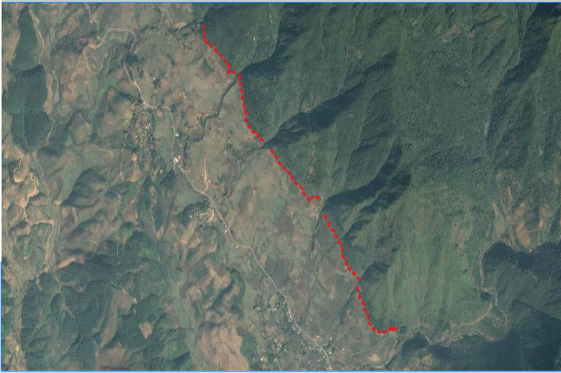  Photo 1: Boundary line (red) for villages of Ho Bon, Nam Bon 1, Nam Bon 2 | 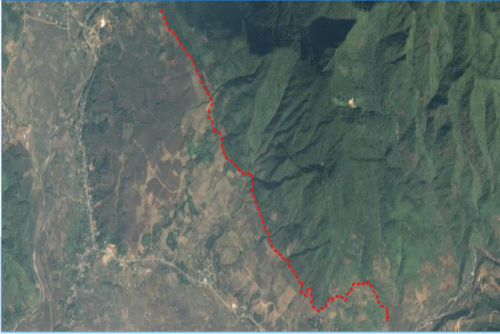  Photo 2: Boundary line (red) for villages of Na Lai, Na Khoang, Ho Ta

Mapping: The objective of mapping was to draw the map with positions of trees, more specifically:
- To make digital data of boundaries and polygons of agriculture land adjacent to the Protection Forest by each land owner
- To print out the map of the boundaries between protection forest and agriculture land
Documentation: Result of field survey and mapping was combined into official documents for:
- To make reports on survey results that include the locations of boundaries, situations of the boundary areas and agriculture land adjacent to the Protection forest
- To make a list of agriculture land owners adjacent to the protection forest
- To make a report on planting activities which include number of planted trees, survival rate survey results, supplemental planting results

COLLECTION OF KNOWLEDGE FROM LOCAL AUTHORITY
The idea of establishment of boundary planting system was firstly shared with Lai Chau Provincial Project Management Unit (PPMU) for comments. The PPMU strongly supported the Project Plan and gave valuable feedback in terms of planting area, tree species, and specification. At the district level, the designed document was sent by the Project to Tan Uyen District Agricultural office for comments and quickly got officially positive letter. Furthermore, the Project also worked closely with Tan Uyen District Protection Forest Management Board who is the owner of protection forest. This Board has rich experience in local forestry species and provided consultancy service on document design.

TECHNICAL TRAINING
After designing document, the SNRM Project offered technical training classes to all households or tea garden owners in April 2018, before delivery of seedlings. The training divided into two parts for one day, in-class in the morning and practice in the afternoon (Table 1).
Table 1: Summary of training information for boundary planting
No | Village | No. of training class | Participant
 |  |  | Total | Male | Female
1 | Hô Ta | 1 | 13 | 7 | 6
2 | Nà Khoang | 1 | 10 | 8 | 2
3 | Nậm Bon 1 | 1 | 3 | 2 | 1
4 | Nậm Bon 2 |  | 9 | 8 | 1
5 | Nà Lại | 1 | 10 | 6 | 4
6 | Hô Bon | 1 | 15 | 13 | 2
Total |  | 5 | 60 | 44 | 16
In-class part generally introduced farmers about objectives of the plantation and then techniques of planting and tending and diseases prevention. For example, trees are planted 5 m apart and the lower branches are pruned after a year of planting to encourage upward growth and minimize knotting. In the afternoon, all participants had an opportunity to practice the trained knowledge such as how to dig a pit and its size, fertilizer application and so on. Trainer was from Tan Uyen Protection Forest Management Board with many years of experience in forestry sector.
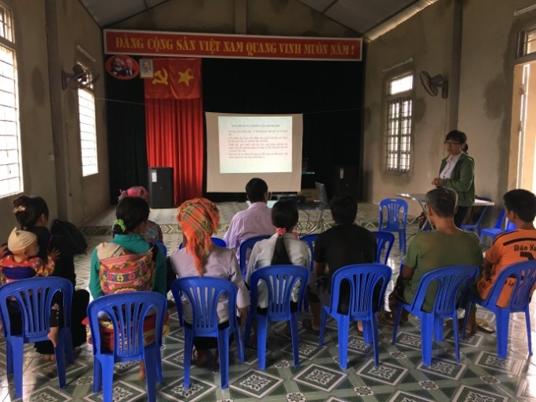 | 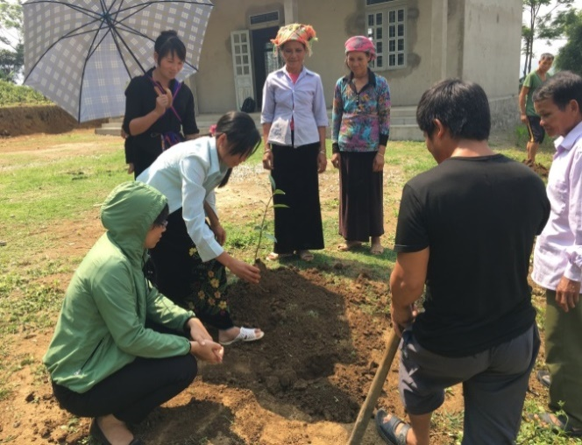
Photo 16: Technical training on boundary planting | Photo 17: Practice planting
As a result, farmers were actively participated in the training, both in-class and practice sections.

PROVISION OF SEEDLINGS AND PRODUCTIOIN INPUT
Seedlings and fertilizers were freely provided to the households for planting in 2018 and 2019 (Table 2). For supplementary planting in 2019, relevant farmers were requested to carefully count at the field for number of all missing trees. About 320 seedlings have been delivered in 2019 to the households for all missing trees because of natural death, landslides, thieve and so on. The figure of seedlings providing in 2019 indicates the survival rate at 72% after one year planting. This has considered being somehow acceptable for forestry planting trees.
Table 2 Summary of seedlings and fertilizer provided by the Project in 2018 and 2019
No. | Village | No. of households |  | No. of seedlings |  | Fertilizer (NPK) (kg)
 |  | 2018 | 2019 | 2018 | 2019 | 2018 | 2019
1 | Hô Bon | 15 | 5 | 300 | 16 | 60.0 | 3.2
2 | Nậm Bon 1 | 4 | 0 | 77 | 0 | 15.4 | 0
3 | Nậm Bon 2 | 15 | 12 | 241 | 78 | 48.2 | 15.6
4 | Nà Lại | 10 | 10 | 106 | 28 | 21.2 | 5.6
5 | Nà Khoang | 10 | 10 | 200 | 74 | 40.0 | 14.8
6 | Hô Ta | 13 | 13 | 218 | 124 | 43.6 | 24.8
Total |  | 67 | 50 | 1,142 | 320 | 228.4 | 64.00

MONITORING TREE DEVELOPMENT
For monitoring the tree development, the Project has at first set up some basic indicators in the Table below. The important target focused on the survival rate; ideally, monitoring should be conducted out during the first four years and the system would be established by the fourth year with at least 90% survival of trees.
Table 3: Monitoring indicator for boundary planting
No. | Monitoring indicator | Unit | Target
1 | No. of planted trees | Tree | 1,142
2 | No. of villages | Village | 6
3 | No. of HHs | HH | 67
4 | Level of acceptance of local farmers | % | 100
5 | Survival rate | % | ≥ 90
6 | Planting location: Planted on boundary land between protection forest and agricultural land

ACHIEVEMENT
At this point in time, it is too early to evaluate the economic impact, gained mainly from edible seeds and timber as only one and a half years have passed since the boundary trees were planted. However, there are some initial achievements presented below.

MANAGEMENT LIVESTOCK DAMAGE
Livestock, referred mostly to buffalos and goats raised by villagers, can be the most serious problem destroying planted trees and crops here in Phuc Khoa Commune. Michelia species is vulnerable to livestock damage through browsing; farmers reported that buffalos and goats like eating Michelia leaves and possibly stepping on the trees. According to the Socio-economic Survey conducted by the SNRM Project in 2016, the number of buffalos and goats in Phuc Khoa commune reached 550 heads. Big animals seem less and less being raised by farmers over years. The reason is that there is less pasture area for grazing livestock. Animals, particularly buffalos, were often grazed and watched by kids on agricultural land and forestry land including protection forest.
The SNRM Project has proposed and encouraged villages to apply several management measures below. Boundary trees damaged by animals reported only few cases or about 2-3% of planted trees.
- Education of communities, particularly for young children, on recommended livestock management practices like tethering and close-watching grazing during the period when trees are vulnerable to livestock feeding. As it was rather difficult to gather children for meetings, parents were always asked at village meetings to educate their children for newly planted tree protection.
- Placement of fence around individual trees for protection (see Photos 1 and 2). Farmers just simply needed to cut off the bottom of a 50kg-size rice sack and cover the tree using 4 sticks. This measure is easy to apply, but trees were protected very well from animal damage. Buffalos, particularly goats, cannot see the trees and then no try to destroy the bag.
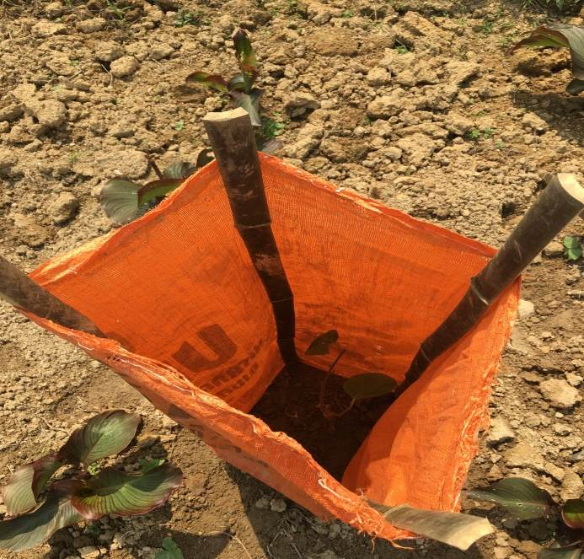 | 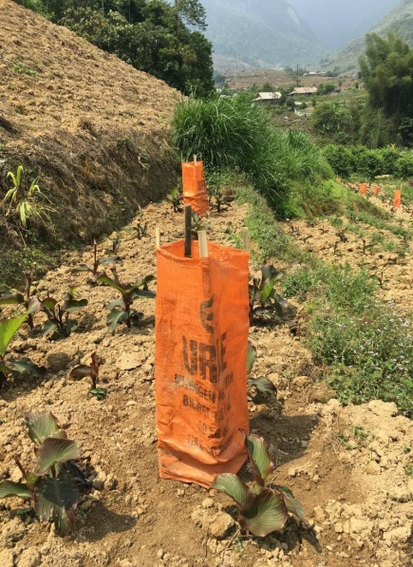
Photos 1 and 2: Management measure for newly planted trees from animal damage
- Enforcement of community by village regulations for livestock management. All livestock owners were asked to attend village meetings for livestock control and responsibility of punishment.
- Involvement of local authority. Commune leaders also urged all villages to protect trees, including boundary trees.
- Encouragement of inter-village collaboration. The fact showed livestock from this village could damage trees from other village; therefore, any village has responsibility of tree protection not only from its own village but also from other villages.

MANAGEMENT OF DISEASES AND NATURAL DEATH
During training, farmers were provided knowledge on pest and disease management; more specifically, on how to treat some common diseases with Michelia. Luckily, no disease has been reported so far. This is likely to conclude that it could be from the selection of the tree species which is hardy to most known pathological problem and healthy seedlings. Before planting, all seedlings were checked carefully in the nursery; only strong healthy seedlings were selected and delivered to farmers.

MANAGEMENT OF DROUGHT
The risk of drought was managed by measure of early planting of strong healthy seedlings. Farmers were encouraged to plant trees at the beginning of the rainy season, in June. Furthermore, measure of good silvicultural practices was also introduced by the Project. Farmers were asked to dig deep pitting and apply some fertilizer. By doing so, it promoted higher soil moisture retention and seedlings easily survived. Unfortunately, it is not applicable to promote irrigation because of the steep slope. In reality, it was observed that Michelia is a drought-tolerant tree species.
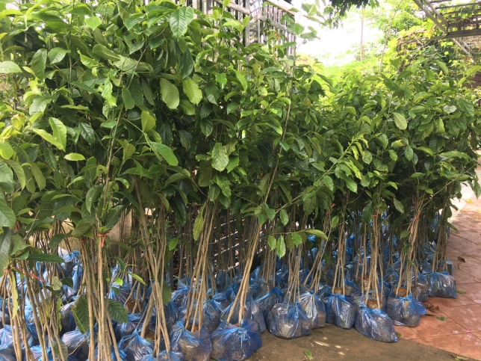
Photo 3 and 4: Tree seedlings to provide to farmers

MANAGEMENT OF TREE DEVELOPMENT
As mentioned above, tree seedlings with average height of 1 meter are currently growing quite well. After one year of planting, the planted tree height has reached about 1.5m and reached to 2m in May 2020.
According to Tan Uyen District Protection Forest Management Board, Michelia species is greatly suitable to the soil in Phuc Khoa. Farmers were requested to tend the trees after planting. It is necessary to prune the trees for better development. The Project frequently monitors and gives advice or support if necessary. For instance, in 2019, the SNRM Project provided seedlings for supplementary planting. Survey of the M&E Round 4 in May 2020 has shown a relatively high survival rate, at 81%. Furthermore, Tan Uyen District Protection Forest Management Board was also interested in observing and evaluating the tree development for its own experience.
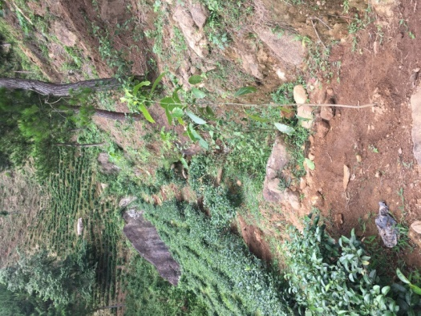 | 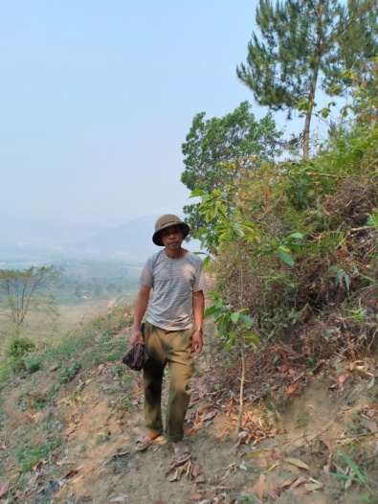 | 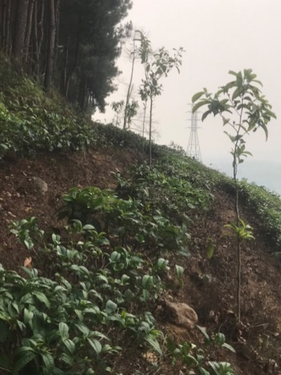
Photo 5: Boundary tree in June 2018 | Photo 6: Boundary tree in April 2019 | Photo 7: Boundary tree in March 2020

POTENTIAL INCOME
The boundary planting system can provide some benefits to the households that manage the system. There is potential income from Michelia, that is, income from edible seeds and timber. Theoretically, Michelia trees start giving seeds after planting of about 5 years and it is recommended to harvest the trees for timer at the age of between 15-20 years. However, the harvest time of seeds and timer also depends much on the soil fertile and tending by farmers. According to local market price, one kilogram of seeds presently costs approximately 2 million VND. Mature Michelia trees can continuously produce seeds for many years. Furthermore, Michelia is well known for its remarkably expensive timber, however; it is highly recommended to harvest seeds and keep the trees.

IMPACT
As mentioned earlier, this boundary planting system was established to monitor and protect forestry land; it is observed that there is so far no land conversion into forestry land from tea garden or agricultural land. .

LESSONS LEARNT
Boundary tree plantation should have been established based on official forest boundary; in other words, the boundary trees should be planted on the margin of officially delineated agricultural land and forestry land. Unfortunately, there is no official boundary and map existing in the local authorities; therefore, the plantation has been established on actual edge of agricultural land and forested land. Nevertheless, it somehow plays an important role in reminding farmers for not extending into forest.
It is very important to get fully agreement from tea owners who have the boundary trees on. Without their high level of interest and participation, it would be extremely difficult to establish the system and it would be not sustainable. To get the tea owner involved in participating into the system, it requires sound explanation and discussions for the tree line objectives. The fact has showed that this took time; for instance, some households in Ho Bon village first rejected to participate.
The hidden purpose, monitoring and limitation of continuous extension into forest, should not be widely discussed and mentioned with tea farmers during any discussion in the village meetings and technical training. The fact has showed that farmers seemed sensitive about the name of “boundary”; for example, in one village, during training, some farmers were really opposed if the system would be reflecting the real meaning of boundary line. Their question was that if the system would be working as an official line. Thus, instead of that, other objectives should be introduced, focusing on general forest management (erosion prevention) and financial purposes (edible seeds and timer). It is also important to explain the tree line would not affect their tea development.
Selection of species to be introduced in the boundary system also plays an important role. As highly recommended by local authorities to select one species for the whole line, the species should also be widely adopted by farmers. Furthermore, other aspects needed to be considered, for instance, local suitability, financial purpose, and sustainability.
It is great important to keep local authority informed and get their involvement in the boundary establishment. Initially, the idea was shared with Provincial Project Management Unit (PPMU) for advice. At the district level, the design documentation was sent to District Agriculture Office for their information and comments. Commune representatives were asked to take part in the field survey for identification of location for plantation.
The boundary establishment process took a rather long time, starting from planning to document design, implementation and monitoring. Planting trees for the boundary system were conducted out in June/July 2018, though the SNRM Project started its field work in Lai Chau in August 2016. Time for planting trees in rainy season should be seriously taken into consideration in the boundary establishment.

RECOMMENDATIONS
The SNRM Project highly recommends local authority, commune and particularly village level, to apply the following measures.
- Improve farmer awareness of protecting the trees from animal damage and other ways of violations such as stealing. Through village meetings, village management boards propagate farmers, particularly children and households having animals, to save the system
- Strictly protect the system from any damage. It is necessary to apply village regulations and discipline any means of tree violations
- Monitor regularly the tree development and identify any problem occurred and report to related agency for necessary treatment
- Provide seedlings for supplementary planting in the first years. This is mainly to cover the lost from natural death and landslides.
- As a multi-functional species, Michelia is highly recommended by farmers to harvest edible seeds for spice. This is to keep the tree line sustainable way.
- Re-plant the tree only when there is no opportunity to harvest the seeds and mature timber.

