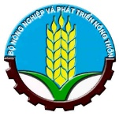

Japan International Cooperation Agency (JICA)
Sustainable Natural Resource Management Project (SNRM)

CASE STUDY

“MULCHING CULTIVATION IN WATERMELON PRODUCTION –
AN INNOVATION AND PROMISING INCOME GENERATING SOURCE FOR LOCAL FARMERS IN LAI CHAU”

Hoang Dinh Quoc

July 2020

This case study was prepared as a part of the Sustainable Natural Resource Management Project (SNRM) funded by the Japan International Cooperation Agency (JICA) and executed by the Ministry of Agriculture and Rural Development of Viet Nam from 2015 to 2020.

The views expressed in this case study are those of the authors and do not necessarily reflect the view of SNRM or JICA.

JICA/SNRM encourages reproduction and dissemination of material in this case study. Non-commercial uses will be authorized free of charge upon request. Reproduction for commercial purposes, please contact JICA/SNRM for a prior and specific agreement.

All queries should be addressed to:

Officer in Charge of Forestry Projects/Programmes
JICA Viet Nam Office
11F CornerStone Building, 16 Phan Chu Trinh, Hoan Kiem, Ha Noi, Viet Nam
Tel: +84-4-3831-5005
Fax: +84-4-3831-5009
Table of Contents

I. INTRODUCTION 1
II. METHODOLOGY 1
III. SUPPORT OF SNRM PROJECT 2
1. STUDY TOUR 2
2. TECHNICAL TRAINING 3
3. MATERIAL SUPPORT 3
4. FIELD TRAINING 3
5. FORMATION OF WATERMELON PRODUCTION GROUP 4
6. MARKETING 4
IV. RESULTS 5
1. OVERALL 5
2. YIELD 6
3. INCOME 6
4. MULTIPLICATION OF SUCCESSFUL MODEL 8
V. LESSONS LEARNT 9
VI. RECOMMENDATIONS 10

INTRODUCTION
The Sustainable Natural Resources Management Project (SNRM), funded by Japan International Cooperation Agency (JICA), started its field work in Lai Chau Province in August 2016 and focused on two main parts, livelihood development, and forest management and development. The SNRM Project promotes livelihood development activities which contribute not only to income generation, but rather to forest enhancement and to reduce deforestation /degradation. And supporting watermelon cultivation is one of the pilot activities belonging to livelihood development.
Since over 10 years ago, farmers in Phuc Khoa Commune, Tan Uyen District, Lai Chau Province tried to grow watermelons on rice paddy and noticed that watermelons could be grown here. The fruit tastes rather sweet and be mostly consumed by local people. Thus, Phuc Khoa has become a famous watermelon-growing center in the region. About more than 10 ha of land are yearly cultivated watermelons in Phuc Khoa. On average, the traditional farming practice yields about 1 ton per 1,000 m2 or 10 ton per ha; offering VND 8 million or VND 80 million, respectively. Compared with other crops, watermelon makes higher profit and can be a good source of income. However, this traditional practice or local farmer’s own experience applied for watermelon production remained quite low productivity and there is much potential for increasing the yields and thus profits.
Mulching cultivation system with agricultural films in watermelon production has become a popular agricultural practice in many different parts of Vietnam. However, this practice was still completely new to farmers in Phuc Khoa though watermelon has been produced there for a long time. In 2017, the SNRM Project started introducing the agricultural mulching system to watermelon farmers in three villages, namely Nam Bon 1, Nam Bon 2 and Pac Khoa villages in Phuc Khoa Commune. Results after four cropping seasons applying agricultural mulches showed a markedly high yield, giving the farmers good profits compared with the traditional planting techniques.
In Nam Bon 2 and Nam Bon 1 villages, three watermelon production groups (PGs) were established with 46 members in 2019 and 2020 with the support from the SNRM Project, aiming mainly at transferring new techniques as a group, producing better quality and large production and gradually accessing higher-value markets.

METHODOLOGY
Watermelon is planted in late January and harvested in May in Phuc Khoa. For many years, watermelon has traditionally been produced in three villages of Nam Bon 1, Nam Bon 2 and Pac Khoa, without preparing ridges during land preparation, but with direct sowing method with 3-4 seeds in one digging pit, limited manure application and not using agricultural films to reduce pests/diseases. Furthermore, at several village meetings, the farmers complained that seed supply was unreliable and thus requested to learn about modern cultivation techniques. Farmers believed they had been growing watermelons with low quality seeds and poor farming methods, resulting in problems of diseases and unstable yields over the years. Watermelon seeds are available at different prices at local markets, causing low germination rates and affecting fruit quality as well.
Based on the situation, in 2017, the SNRM Project planned to initiate a pilot by establishing a model with several households to introduce agricultural mulches in watermelon production. The idea of this support is to simply solve the production constraints and link them with reliable input suppliers. Theoretically, agricultural mulching system has multiple purposes such as to increase fruit quality, improve moisture or prevent evaporation to maintain humidity, hinder weed growth, control pests and diseases, and save labor. Furthermore, some other economic benefits include higher yields, earlier harvests, and reduction of herbicide/pesticide and fertilizer use. Therefore, agricultural mulching technique is considered as an innovative technology in agricultural practices.
To select households participating in the model, several village meetings were organized and the SNRM Project presented the current techniques and also introduced new technology that was applied in other regions and finally asked for participation or registration. Some conditions and the Project’s support policy were also discussed in order to participate in the model. More specifically, interested farmers needed to make sure to completely follow the project’s instruction as well as to contribute 50% of the material costs into the village fund for the prioritized use for forest management activities; for instance, to purchase and provide equipment for village patrolling teams. Furthermore, farmers were also required to have at least 500 m2 and 300 m2 of farmland in order to participate in the model activity and PGs in 2018 and 2019/2020 respectively.
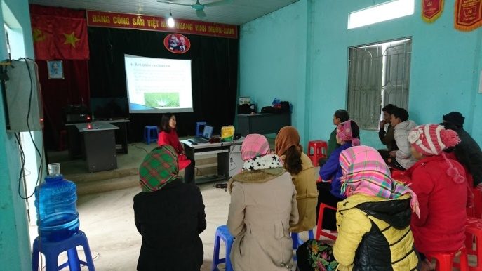  Photo 1: Village meeting introducing new farming method | 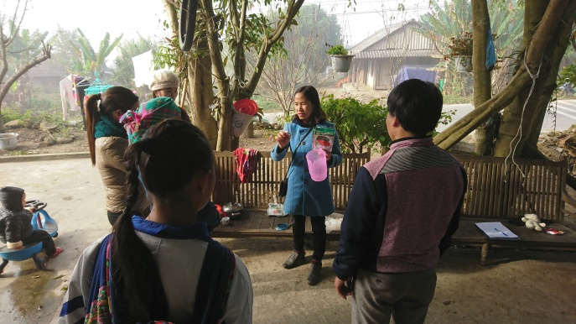  Photo 2: The trainer discusses with interested farmers

In the first cropping season of 2018, the trial was initiated with 7 households of Nam Bon 2 village. In 2019, to multiply from the trial, the Project supported 10 households, and in 2020 only 46 households/members within three PGs supported. Specific support from the Project is presented in the next section.

SUPPORT OF SNRM PROJECT

STUDY TOUR
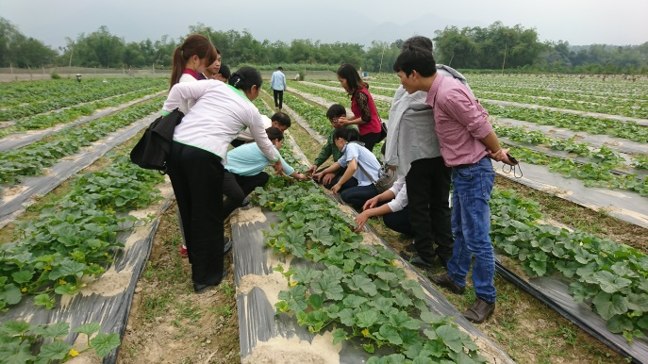

Photo 3: Field visit during the study tour
In 2018, the Project organized a study tour to another province where agricultural mulching had already been applied in watermelon production in order to observe and discuss with farmers there. Not only these 7 farmers in the model, but other stakeholders were also invited to join the visit, including a contracted trainer from the District Center for Agricultural Services, key persons from other villages of Nam Bon 1 and Pac Khoa, and a commune extension worker.
The study tour participants visited Tuyen Quang Province where watermelon producers had been successfully applying agricultural covers in watermelon production for years. Phuc Khoa farmers could clearly observe the field with agricultural mulch use, and learnt lots of actual experience. There were various experiences shared among the Phuc Khoa farmers. The visit was interesting and really worthwhile to the farmers before starting the model.

TECHNICAL TRAINING
Technical training was held about one month before the cropping season started. In the four crop seasons of 2018, 2019 and 2020, indoor training on mulching technique was especially organized for those farmers participating in the model. The training was compulsory for the model farmers; however, other farmers who were interested in learning the new method were also welcomed to join. The one-day training provided by the experienced trainer consisted of two main parts, theory and practice. While the theory part in the morning gave a broad view about the new production method and some clear comparisons between the traditional practice and mulching system, in the afternoon session, the participants were guided to practice all the stages, including land preparation, application of mulching films and so on. Furthermore, the training in 2019 and 2020 clearly drew some lessons learnt from the first crop production so that the farmers could avoid repeating the mistakes from the previous years.

MATERIAL SUPPORT
The Project supported production inputs including seeds, agricultural films for mulching, pesticides and fertilizers. There are numerous varieties of watermelon seeds available released by seed companies. However, two varieties, Hac My Nhan and Hoan Chau were commonly preferred by Phuc Khoa farmers due to higher yield and fruit’s sweetness. In the first year of support, results from 2 varieties applied (Hac My Nhan and Hoan Chau) showed that Hac My Nhan was better in quality and development. Hence, the Project encouraged the farmers to use Hac My Nhan as it seemed more suitable watermelon variety. The source of seeds and other materials was guaranteed by and contracted with the District Center for Agricultural Services. All the material cost was covered by the Project, in turn the participating farmers were asked to contribute 50% of the cost into the village fund. Each household needed to contribute VND 631,000 in 2018 and VND 400,000 in 2019 and 2020 into the village fund used for forest management related activities as a top priority.

FIELD TRAINING
In 2018, 2019 and 2020, the Project contracted with an experienced trainer for the delivery of field training or provision of production guidance for the whole watermelon growing season, from February to April and from July to October. This training was always held in the field and at all stages of the crop season. More specifically, the interested farmers were trained on soil and land preparation, seed treatment, seed sowing, mulching – use of agricultural films, weed management, pruning, water management, fertilizer/nutrient application, insect and disease control, harvesting and storage. The participants were often organized as groups and participatory approach was applied, encouraging farmers to share experiences and learn each other. This is a group-based learning process or Farmer Field School (FFS) in other term, which is broadly applied in Asia and particularly in other regions of Vietnam. The trainer clearly provided production guidance and each farmer later on followed trainer’s instruction and implemented on their fields until the trainer finally accepted.
The trainer often visited the field and checked out whether the participants technically carried out the work as guided. Depending on the crop stage, the trainer paid daily or weekly visits to the farmer’s field. When any problem occurred or the participants required any further support during the cropping season, the trainer could come at any time to sort them out. Regular visits also helped the trainer not only observe the crop development but also recognize any problems or diseases occurred. According to the trainer’s experience, once a disease appears, it is extremely difficult or can be impossible to treat it as it spreads so rapidly. Or farmers could often make mistakes, for instance, how to keep the solid moist, but not waterlogged or reduce watering once fruits are growing and try to avoid wetting the leaves and overhead watering.
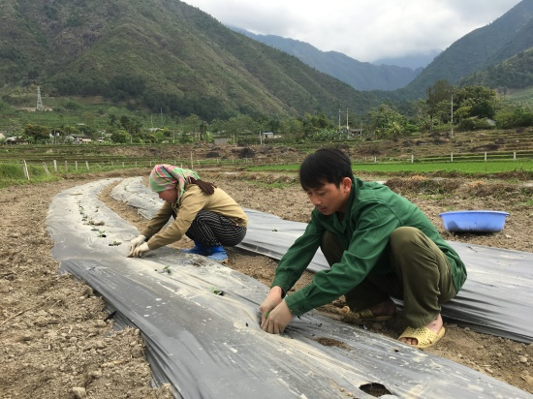  Photo 4: Farmers install agricultural films | 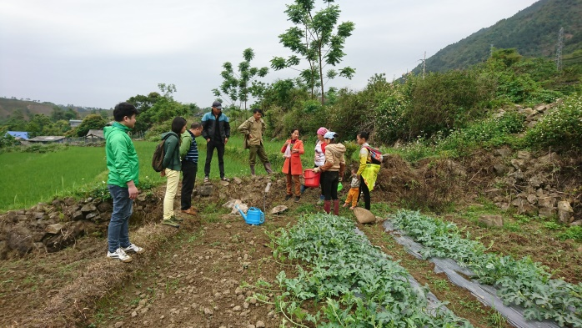  Photo 5: The trainer shows how to use fertilizer

FORMATION OF WATERMELON PRODUCTION GROUP
The idea of forming a watermelon PG by the Project was not only completely new with Phuc Khoa farmers but also with the local commune authorities. It would be easier and faster to facilitate the group formation if other crop production groups exist in the area. Fortunately, there is a newly established tea PG in Tan Uyen Town though it is not working in watermelon production but the PG possibly can play as a great model for Phuc Khoa watermelon farmers to learn. The Project guided some Phuc Khoa farmers to visit the tea PG to share experience and learn from them. This was really good to start with before the formation of the PG as the watermelon farmers understood the group principles as well as how to operate and manage it sustainably. In early 2019, one watermelon PG was officially formed with 9 households in the village of Nam Bon 2. According to Tan Uyen District and Phuc Khoa Commune Farmers’ Union, this PG has been recognized as the first PG in the commune and the first PG in watermelon production in the district as well. In 2020 this PG increased its membership to 24. Also in 2020 two new PGs were formed in Nam Bon 1 village with 22 members. The titles of the PGs, Nam Bon 2 Watermelon PG, Nam Bon 1 Watermelon PG 1 and 2, were originated from the names of the villages where the farmers produce watermelons, confirming the geographical production which possibly opens a room for geographical indication in future. The PG Management Boards then elected three key positions namely head, vice head and cashier-cum-secretary. In general, the PGs aim at following the same watermelon production technique which refers to agricultural mulch use, sharing production experience and marketing the product.
The formation of the PGs in Phuc Khoa, facilitated by the Project as a pilot, received huge support from local authorities, such as the Commune People’s Committee (CPC), commune Farmers’ Union and Women’s Union, and district and provincial Farmers’ Union.

MARKETING
Most of the watermelon marketing in Phuc Khoa is done through a traditional way. Farmers simply sell their produce on roadside near home or a few traders come and then farmers sell at farm gate. Therefore, one can buy watermelons at any point about 2 km along the main road. There was no specific place so-called a selling point.
The Project has supported to establish a selling stand on the roadside where all the watermelon PG members can market their products collectively. The stand made by bamboo only looks environmental friendly and is placed visible for consumers from both sides towards Lai Chau City and to Tan Uyen Town. Consumers are attracted and easily recognize the PG’s stand not only by a special design but also by the banners and stickers on the fruits.
The banner was designed carefully, indicating safe fruits grown in Nam Bon 2 Village of Phuc Khoa Commune. The banners were largely printed and hung on the stand to attract consumers.
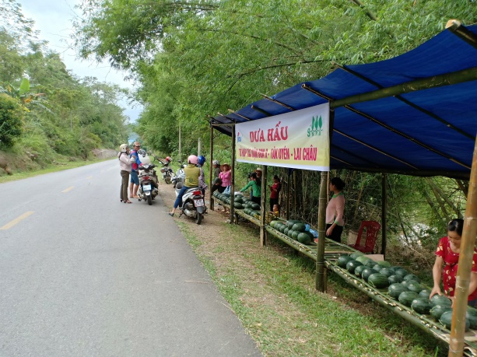  Photo 6: Selling the produce at roadside stand | 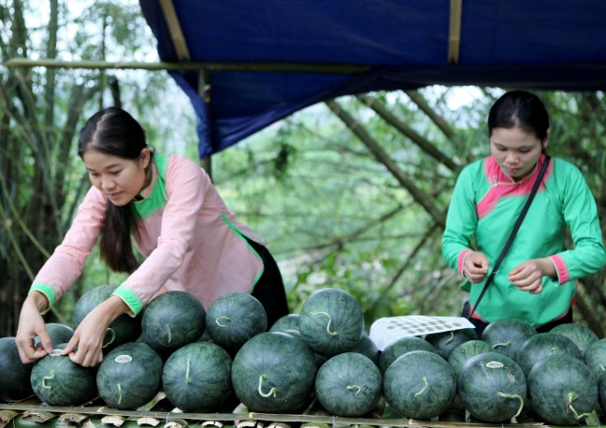  Photo 7: Placing stickers on the produce

A small piece of sticker for sticking on watermelons was also developed with support from the Project to ensure the produce of the Nam Bon 2 Watermelon PG. The text indicated on the sticker is the brand name that is ‘Nam Bon 2 Watermelon Production Group’. Another purpose of placing stickers on fruits was to test if consumers are interested in caring the sticker and if they were willing to pay premiums for fruits with stickers.
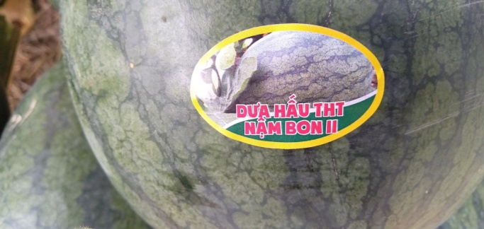  Photo 8: A sticker stuck on watermelon | 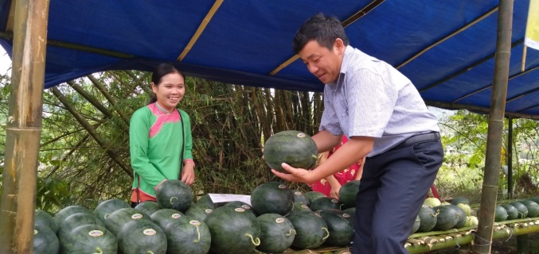  Photo 9: A consumer looks at the sticker

RESULTS

OVERALL
In general, production in the four cropping seasons of 2018, 2019 and 2020, with applying the agricultural mulching system instead of the traditional farming method, relatively went well. The results in the three years showed that the participated farmers were extremely satisfied with growing watermelons with the new farming method and promised continuity in the next seasons. The results from the second season again confirmed the positive impact of the new practice and the farmers were totally able to apply the innovative technology. Benefits reported by the farmers include better productivity and higher yield thus increased income, faster fruit development, less labor, less disease and insect affection, larger fruit size, etc. Again, the farmers reported they would continue applying the new production method in the next seasons.

YIELD
In the first crop season of 2018, data of all households (7 households in the first crop and more in the next crop seasons) participating in the model indicated that the yield of watermelon ranged from 2 to 2.8 tons per 1000 m2, equivalent to 20-28 tons per ha. The average fruit size reported was from 2 to 3 kg per fruit, the largest size could reach to be more than 5 kg. The yield of each household varied with specific growth conditions such as soil and/or water availability. In the second crop season of 2019, the yield was similar with the one in 2018, which is about 2.5 tons per 1,000 m2 or 25 tons per ha. In summary, the yield from new farming practice introduced by the Project was rather stable, gaining at least double yield compared with the traditional farming method which is maximum about 1 ton per 1,000 m2 or 10 tons per ha. Many households with the traditional farming method in 2019 had no harvest or very low productivity (see Image below) due to dry weather and poor farming method. In 2020, the yield has significantly decreased to about 1.8 tons per 1,000 m2 or 18 tons per ha. The reason for this sudden lower yield is because of unfavorable weather which never happen like this before. Watermelons were negatively affected by hail damage and later too hot and rainy climate.
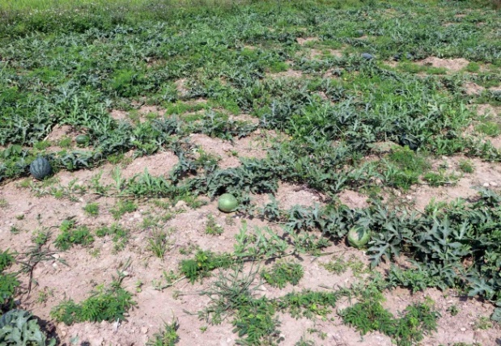  Photo 10: Products with traditional cultivation | 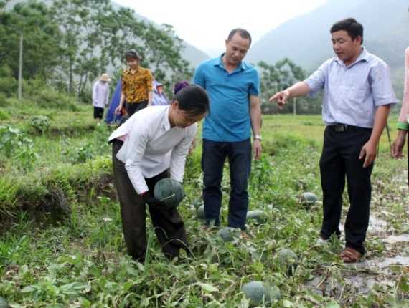  Photo 11: Products with agricultural mulching system

INCOME
The price of watermelons in 2018 quite fluctuated, started from VND 15,000 per kg and rapidly dropped to VND 10,000 and VND 8,000 in the peak harvest season; thus, the income from the model was calculated using the average price of VND 8,000/kg. Based on the yields, 2 to 2.8 tons per 1,000 m2, the farmers earned VND 16 million to VND 22.4 million. The actual income was a bit higher as better prices at the early harvest.
In 2019, the price was quite stable, remained almost at VND 15,000 per kg, even during the peak harvest time – still a competitive price on the market. This price was about VND 1,000 to 2,000 per kg higher than produce from traditional method due to the bigger size and produce of the PG. The stable high price offered an opportunity for increasing income; 2.5 tons of watermelons per 1,000 m2 is worth VND 37.5 million. | The main watermelon season in Phuc Khoa is about 3 months, from February to April; in 2019, income from watermelon applied agricultural mulching system gained VND 37,500,000 per 1,000 m² or VND 375,000,000 per ha, offering farmers an earning of at least 6 times as much as income from rice production.
This price was unpredictable, according to the local farmers, traders and/or consumers often offered different prices during the harvest time. Compared with the previous years, the price in 2019 increased by VND 3,000 to 5,000 per kg. Watermelon production by 9 households of the PG in 2019 totaled more than 6 tons, equivalent with VND 200 million, which gained a higher profit than last year crop.
In 2020, as mentioned above, the yield was at about 1.8 tons per 1.000 m2, and the price from VND 10 to 12,000 per kg. This means the income, VND 18 to 21 million per 1,000 m2, is lower than previous crops. Unfortunately, the price was also negatively affected by the pandemic of COVID-19.
Irrigated rice is traditionally and commonly produced in Phuc Khoa commune. Compared with the income from rice production, the income from watermelon had gone up within a short period. While the income from rice was estimated about VND 6 million per 1,000 m2, watermelons could generate far from this.
Production cost for 1,000 m2 consisting of materials and labor cost was roughly estimated about VND 8 million, giving a farmer a net income or profit of VND 8 to 14.4 million. Importantly, the farmers themselves worked and they could handle all the production work but no need to hire extra labor. Therefore, labor estimated for calculation of profits here was based on market price, about VND 100,000 per man day. In reality, family labor is always very difficult to estimate as they often do not work full day but only a few hours a day. Excluding labor cost which is not related to cash payment, material cost only was estimated at about VND 5.4 million for 1,000 m2; according to the farmers’ perspective, the profit reached VND 10.6 to 17 million.
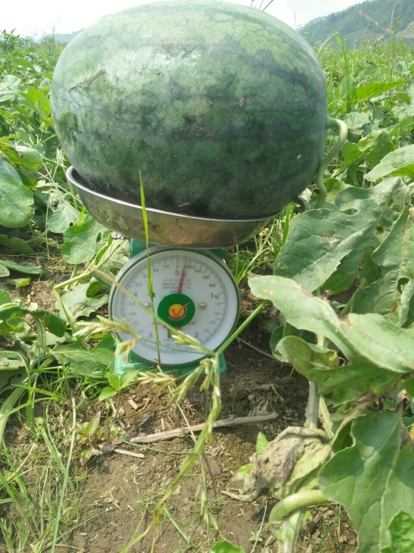 | 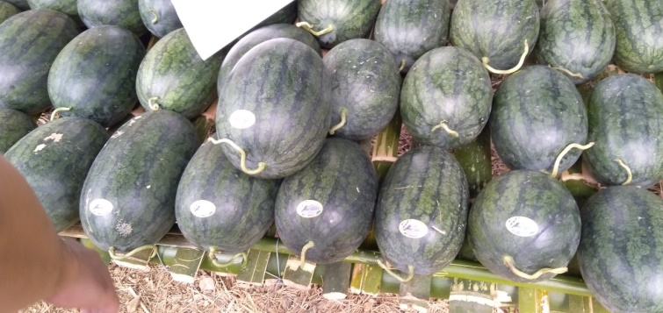  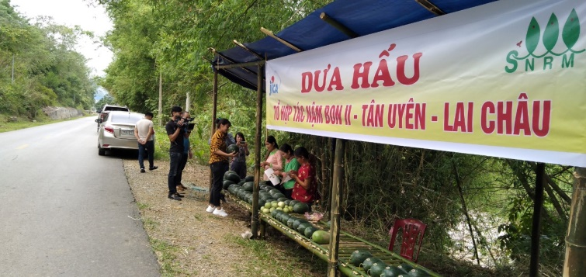
Photo 12: Produce by the PG members
While some farmers were very satisfied with the results and can clearly see the benefits of applying the new farming technique, others had to cope with large fluctuations in benefits from traditional farming method as depicted in the box below:
- Mr. Tèo Văn Tải in Nậm Bon 1 village: Profit in 2016 was reported as VND 2.5 million per 1,000 m² but in 2017 it was only enough for home consumption due to disease problem.
- Mr. Lý Văn Ván in Nậm Bon 1 village: In 2016, profit per 1,000 m² was reported as VND 3 million. In 2017, he had no harvest, no profit, severe loss due to crop disease.
- Mr. Vàng Văn Quỳnh in Nậm Bon 1 village: Profit per 1,000 m² in 2017 was VND 1.5 million.
- Mr. Vàng Văn Chủng in Nậm Bon 2 village: In 2015, profit of VND 5 million for 1,000 m² but no harvest and no profit in 2017 due to disease problem.
From the income perspective, agricultural mulching system is considered as a successful farming method that should be encouraged to be extended. This was confirmed and supported by local authorities at the Field Workshop organized by the Project in 2018. The outcomes from the new farming technique with positive income were widely posted on mass media including local and national websites and local television in 2018 and 2019.
The Watermelon Production Groups entitled Nam Bon I and II PGs have been successfully established and operated; farmers were able to receive several beneficial services such as technical training, cheaper inputs and access to market. Formation of such production groups always needs to be facilitated, encouraged and supported before it could operate itself. Other advantages of production groups are apparent, mainly increasing experience sharing thus contributing the increase of adoption rate of new farming method, lowering production costs and avoiding unavailability of production inputs in local markets when ordering as a group.
Traditionally, individual farmers mostly sell small amounts of produce at the farm gate and roadside stands. Some traders also come and buy directly from the producers. However, gathering the PG’s produce to sell at a special roadside stand designed for the PG has greatly attracted consumers. The banners and stickers play an important role in ensuring the safe crop produced locally and from the PG. Interestingly, there were more consumers buying produce at the PG’s stand than other individual’s stands. Moreover, the PG’s stand and their produce also rapidly spread online via Facebook and attracted other consumers elsewhere.

MULTIPLICATION OF SUCCESSFUL MODEL
This new practice of watermelon cultivation can be considered as a successful model in terms of planting area and number of households applying the technique trained over the last crops (see Table 1). The planting area applied with this practice has dramatically increased, particularly in Crop 4; it is likely to observe only this new practice in watermelon field. The extended area is from not only within those households supported by the Project but also households outside the Project’s support. As Project’s support area is rather small, first crop 500m2 and latter 300m2, thus, those households in the model also applied the same method for the rest of their planting area. The positive impact of this practice has later also been influenced by other households, convincing them not to apply the traditional cultivation practice any more.
Table 1: Planting area and households applying new practice of watermelon cultivation
Indicator | Crop 1  (2-5/2018) | Crop 2  (2-5/2019) | Crop 3  (7-10/2019) | Crop 4  (2-5/2020)
Planting area (m2) | 3,500 | 6,100 | 16,500 | 74,000
Number of PGs | 1 | 1 | 1 | 3
Number of households supported by Project or PG members | 7 | 10 | 24 | 46
Number of households not supported by Project | 0 | 0 | 0 | 33

LESSONS LEARNT
Extension of the new farming practice is the focal point of the SNRM Project. As such, the following key points were identified for further development:
- The Project has so far directly benefited some 46 watermelon farmers. After three crop years applying agricultural mulch, it has been confirmed the yield applied agricultural mulching is quite stable and higher than the traditional technique. The farmers themselves can clearly see the benefits of doing this, for example, faster growth, less disease and insect affection, labor saving, higher yields, faster sales, and higher income.
- The number of households applying the new farming method has increased from 7 households in 2018 to 10 households in 2019 and 79 households in 2020, implying agricultural mulching is gradually adopted in Phuc Khoa Commune. Moreover, planting area applied with agricultural mulches without the Project’s support, or self-invested, has increased in the second crop year (2,000 m2) and specifically in the fourth crop year, 74,000 m2, indicating farmers are interested in and willing to adopt the new farming techniques. Though its profit has apparently and positively shown in 2018, the adoption rate remains below the Project’s expectation. However, this seems to be normal in adopting new innovation technology because farmers are quite skeptical in applying new practice; thus, it often takes time. Nevertheless, selection of first farmers as successful pioneers is always important to increase the adoption rate.
- The fact shows production inputs for watermelons, for instance, good quality seeds, agricultural films, pesticides are not easily found and bought in local markets, but presently these need to be ordered from other regions such as Hanoi. It means that it is relatively difficult for individual farmers to order and buy a small amount. The main reason for being unavailability of inputs is because of watermelon production is not so popular in Lai Chau and therefore, specific inputs for watermelon are not imported by traders.
- Farmers are often not good at identifying ripe watermelons because some fruits were harvested when not fully mature. According to the Project trainer, once picking up immature fruit will stop ripening and thus affecting the quality. Maturity of the fruit is indicated when the fruit produce light green color. Furthermore, maturity and quality are always of prime importance in marketing watermelons. In short, immature harvest would negatively influence Phuc Khoa watermelon’s reputation. Moreover, other farmers, often farmers applying traditional farming method, are eager to harvest as early as possible because earliness usually results in higher prices. This is in line with negative quality impact, thus affecting product reputation.
- The Project played a very important role in connecting all the stakeholders including farmers, local authorities (commune, district…) and mass organizations (Farmer Union, Women Union…) and initially offering technical and material support. It is also necessary to monitor, review and encourage the PG members to maintain the activity sustainably. In the long term, local mass organizations such as the Farmers’ Union and Women’s Union are the best to conduct the tasks as any project has limited time.

RECOMMENDATIONS
Based on the results of the three-year implementation, the following recommendations are made for watermelon production and sales in Phuc Khoa Commune.
- The local authorities particularly the Farmers’ Union and Women’s Union at village and commune levels should strongly encourage farmers by organizing meetings to talk more about the benefits and advise them to adopt the new farming method, not only for watermelon production but also for other crops. One important support needed is to help farmers to be able to access to loans from formal or informal financial sources by establishing a microcredit scheme. It is often seen as lack of investment by farmers.
- The District Center for Agricultural Services should organize regular technical training and at the same time provide reliable inputs and materials such as seeds and mulching films. Moreover, technical assistance is also great of importance, for instance, improved harvesting by picking up when the fruit is completely ripe or mature also offers potential to increase quality and profits. Regular meetings, at least before and after the cropping season, within the PG members should be organized to share experiences or agree on harvesting schedule and get some lessons learnt.
- There is much opportunity for watermelon farmers in Phuc Khoa to extend the planting area. Generally, there is an oversupply of fruits during the peak season, leading to low prices. However, the selling prices in Phuc Khoa in 2019 remained almost unchanged even during the peak season. This means that the demand for watermelon in 2019 was rather high and the supplies were inadequate. To support the productivity of watermelon in Phuc Khoa, several weaknesses must be addressed such as improving irrigation system and supporting other farmers applying agricultural mulches to achieve a critical mass of production and access markets. There is potential for the increase of watermelon production area by irrigation system improvement. Much of land in one crop of paddy rice is facing a problem with water shortage and the land is often useless for a long time. By improving the irrigation system, this would be an opportunity to diversify into high-value crops such as watermelon production. Another potential to increase the productivity and profits is to cultivate watermelon in out-season as most of the PG members are practicing.
- Currently, watermelons produced in Phuc Khoa are largely consumed by local people in Lai Chau Province. However, if watermelon production is to be increased, it is important to engage bigger and higher-value markets such as Lai Chau City, Tan Uyen Town, Than Uyen District and Lao Cai Province. In 2019, the PG members have already received an order from traders in Lao Cai with large volume of 2 tons. However, they could not meet the demand of such large amount. Of course, one thing that also needs to be considered is the competition with producers from the other areas.
- Markets need to be sought when production exceeds local consumption capacity. This possibly happens when the whole area of two crops of irrigated rice in a year would be planted by watermelons with good harvest. For the solutions, such as bigger and more distant markets need to be sought or additional options such as business plan should ideally be advised by the local authorities. Certification can fetch certain premiums over non-certified. Therefore, product certifications for watermelons also need to be planned, depending on specific market requirements such as organic or just basic safe production.
- Establishing market linkage to higher-value markets offers potential to increase profits. One example of price differences is currently retailing in Phuc Khoa for VND 15,000/kg and in Lai Chau City for VND 20,000/kg. It is therefore financially beneficial to transport watermelons for sale to Lai Chau city if the transport costs are less than VND 5,000/kg. With the exception of the trucks for watermelon, this does not appear to be a constraint. The commune has advantages and it should be exploited to its full potential, such as the good road networks linking Phuc Khoa to Lai Chau city and to district towns including Tan Uyen, Tam Duong, and Than Uyen.
- The traditional marketing does not encourage quality improvement. Traders only pay farmers a standard price for all fruit sizes. Farmers particularly the PG members should get price premiums for grading fruits applied agricultural mulching practice. For example, Grade I should receive higher prices. Thus, there is an opportunity for increasing the value of fruits.
- In the long term, farmers need to be trained on preparing business plan and improving bargaining power in marketing their produce. Well-prepared business plan would help farmers avoid imbalance between demand and supply. In reality, farmers also lack the capacity to deal with ordering inputs.
- Farmers are better organized and formed into groups in terms of Production groups for multiple purposes such as self-help, experience sharing, purchase of inputs and marketing. There is much potential for the PGs for accessing to credit and other assistance in formal training. The buyers can deal with the group as a whole rather than with individual farmers because the group can grow enough produce to meet a buyer’s volume requirements.
- It is rather important to select active farmers participating in the model. Successful model depends on not only certain level of investment but also following the strict regulations of the PG; for example, crop calendar, technical standard, selling price.
- Although the Project has been supporting the PGs in production and marketing of watermelons, it is critical for the PGs to consider a shift to other crop(s) in case they face difficulties in future marketing of watermelons. It is strongly hoped that the PGs together with other stakeholders have equipped themselves with sufficient knowledge and skills on management of technical and marketing issues for shifting to the other crop(s).

https://vnanet.vn/vi/anh/anh-thoi-su-trong-nuoc-1014/lai-chau-hieu-qua-tu-mo-hinh-trong-dua-hau-che-phu-nilon-tu-du-an-jica-3870516.html https://baomoi.com/dua-hau-phu-nilon-ben-re-o-ban-vung-cao-lai-chau/c/30693725.epi https://dantocmiennui.vn/xa-hoi/hieu-qua-kinh-te-cao-tu-trong-dua-hau-phu-nilon-o-lai-chau/231431.html https://baotintuc.vn/dan-toc-mien-nui/dua-hau-phu-nilon-ben-re-o-ban-vung-cao-lai-chau-20190513121601612.htm https://phapluat.tuoitrethudo.com.vn/dua-hau-phu-nilon-ben-re-o-ban-vung-cao-lai-chau-21438.html On Lai Chau local Television on 21 May 2019 (https://www.youtube.com/watch?v=Wnu7w_2vEIM); and 22 May 2018 (http://laichautv.vn/truyen-hinh/thoi-su/201805/thoi-su-20h00-ngay-22052018-725685/)

