Japan International Cooperation Agency (JICA)
Sustainable Natural Resource Management Project (SNRM)

CASE STUDY

“VILLAGE-BASED PATROLLING TEAMS – HOW TO MAKE THEM WORK”

Hoang Dinh Quoc
Provincial Coordinator of Lai Chau Province

March, 2020

This case study was prepared as a part of the Sustainable Natural Resource Management Project (SNRM) funded by the Japan International Cooperation Agency (JICA) and executed by the Ministry of Agriculture and Rural Development of Viet Nam from 2015 to 2020.

The views expressed in this case study are those of the authors and do not necessarily reflect the view of SNRM or JICA.

JICA/SNRM encourages reproduction and dissemination of material in this case study. Non-commercial uses will be authorized free of charge upon request. Reproduction for commercial purposes, please contact JICA/SNRM for a prior and specific agreement.

All queries should be addressed to:

Officer in Charge of Forestry Projects/Programmes
JICA Viet Nam Office
11F CornerStone Building, 16 Phan Chu Trinh, Hoan Kiem, Ha Noi, Viet Nam
Tel: +84-4-3831-5005
Fax: + 84-4-3831-5009
Table of Contents
I. INTRODUCTION 4
II. METHODOLOGY AND APPROACH 5
III. ENHANCING VILLAGE-BASED PATROLLING TEAMS 5
1. ESTABLISHMENT OF ACTIVE VILLAGE-BASED FOREST PROTECTION TEAMS (VFPTs) 5
2. TRAINING OF VFPTs 5
3. PROVIDING TOOLS AND EQUIPMENT 7
4. USE OF PAYMENT FOR FOREST ENVIRONMENTAL SERVICES (PFES) IN FOREST MANAGEMENT 9
5. ACTUAL PATROLLING IN VILLAGES 10
6. MONITORING 11
IV. LESSONS LEARNT 11
V. RECOMMENDATIONS 12

INTRODUCTION
In Phuc Khoa Commune, nine Village-based forest patrolling teams (VFPTs) belonging to nine villages undertake forest patrol, protection and fire prevention and suppression activities in a total area of 4,230.51ha under three forest categories as of special-use forest, protection forest and production forest. VFPTs have been established and subcontracted with the forest owner, namely Tan Uyen District Protection Forest Management Board (PFMB) for protection of this forest area.
VFPTs, as contractors, are responsible to protect their contracted forest area in order to yearly receive Payment for Forest Environmental Services (PFES). This payment is only made in case forest area is well protected and undamaged, suggesting the important role of patrolling activity in forest protection and management. However, since established, VFPTs were rather poorly organized and operated improperly, and actual patrolling routine was not completely carried out.
The Sustainable Natural Resources Management Project (SNRM), funded by Japan International Cooperation Agency (JICA), initiated its field work in nine villages in Phuc Khoa Commune, Tan Uyen District, Lai Chau Province in August 2016 and focused on two main parts, livelihood development, and forest management and development. Under the project objectives, strengthening of the forest protection and development is one of the key tasks in the Project implementation.
Based on the situation of the existing VFPTs which necessarily needs to be supported, the SNRM Project assists VFPTs in consolidating and enhancing of their roles and function, expanding to forest patrolling and reporting as well as the role of awareness raising for communities.
This paper aims to provide a good practice on establishment, consolidation and operation of VFPTs in Phuc Khoa Commune. Under the SNRM Project support, all VFPT members were trained, equipped by tools and equipment, and monthly participated in patrolling their contracted forest areas.

METHODOLOGY AND APPROACH
This case study or good practice focuses on the main achievements of forest management and development activities carried out by the SNRM Project. The Project activities in Lai Chau at the village level included REDD+ Pilot Activities consisting of strengthening forest protection and management such as facilitating VFPTs, and livelihood development such as introducing improved cooking stoves, watermelon cultivation models, and fruit tree/vegetable cultivation. The Project organized many village meetings, interviewed with commune and village leaders, trainings on technical supports to beneficiaries, and conducted out field surveys, collected substantial data and collaborated closely with different relevant agencies such as Provincial Project Management Unit (PPMU), Tan Uyen PFMB, Commune-based Forest Rangers (CFR) and Phuc Khoa Commune People’s Committee (CPC) for the Project implementation.

ENHANCING VILLAGE-BASED PATROLLING TEAMS

ESTABLISHMENT OF ACTIVE VILLAGE-BASED FOREST PROTECTION TEAMS (VFPTs)
As PFES is equally paid by households and therefore, basically, each individual or household has responsible to project forest, particularly, in some emergencies such as forest fire; it requires everybody participation. However, to frequently go on forest patrol, according to some VFPT leaders, it would be very difficult to manage and monitor a big group of farmers in this activity, especially for some old and/or female headed households.
In collaboration with CFRs, the SNRM Project always advises villages to establish a small group of farmers, often young and strong men; more importantly, to select only active members who are willing to go patrolling. Perfectly, each VPFT consists of 20-30 members (see Table 1) and every year VPFTs are evaluated and reselected based on members performance. New members might join the team and some may be out because of inactive participation and other reasons such as travelling elsewhere to work.

TRAINING OF VFPTs
Once VFPTs have been established, the SNRM Project arranged trainings on raising awareness and capacity building for VFPTs resulting in that effective support can be provided by these VFPTs. Each year, from 2017 to 2019, nine training courses were organized by the Project for nine VFPTs on forest patrolling at the end of the rainy season (July/August), so that VFPT members could start their work at the beginning of dry season starting in September (see Table 1).
In order to provide enough information and to make sure every VFPT member understands well the work and their responsibilities, the SNRM contracted with a trainer and an assistant for the training. The trainer, prepared a training program and in charge of sharing knowledge, is from of Provincial Sub-FPD and the assistant, facilitated the training course and added actual cases in field, is a Phuc Khoa CFR. The trainer and his assistant have many years of working experience in this area, especially in guiding and supervising the VFPTs’ work.
Each training course lasted for one day and was divided into two parts, theory (classroom session) and practice (in field). Theory was organized in the morning and participants were provided with basic information, knowledge and skills on forest patrolling. The theory part helped the VFPT members to understand about roles of forests, roles and responsibilities of the VFPT members, patrolling and monitoring methods, and skills required for forest patrolling.
Table 1: Total of participants to the technical training on forest patrolling
No. | VFPTs | Number of participants
 |  | 2017 | 2018 | 2019
1 | Phuc Khoa | 22 | 22 | 22
2 | Pac Khoa | 17 | 25 | 25
3 | Ho Bon | 16 | 22 | 22
4 | Na Lai | 18 | 20 | 20
5 | Nam Bon 1 | 22 | 21 | 21
6 | Na Khoang | 24 | 20 | 20
7 | Ngoc Lai | 22 | 22 | 20
8 | Ho Ta | 30 | 30 | 30
9 | Nam Bon 2 | 21 | 20 | 20
Total |  | 192 | 202 | 202

Field practice, in the afternoon at the field, helped all members develop patrolling plans (i.e., use of maps and guidelines for reporting), practice forest patrolling and recording. Participants were guided thoroughly and practiced to make sure that everybody understood contents of the VFPT report form and how to fill up the form. Several reporting forms were printed out for each participant to practice.
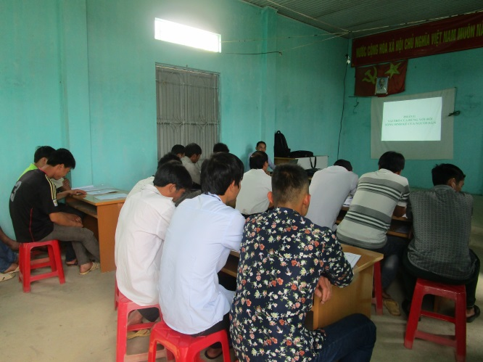 | 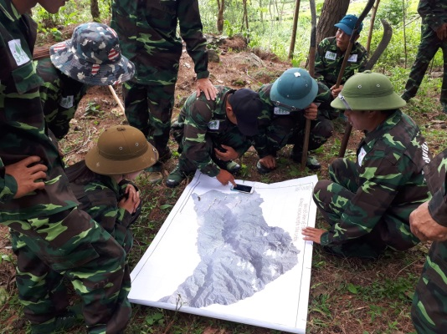
Image 1: Classroom session for the VFPTs | Image 2: Field practice for the VFPTs
Latest satellite image map was well prepared by the Project with sufficient data including plot boundaries, forest status, forest protection in-charge villages, forest types, and so on. Trainer and VFPT members carefully previewed and familiarized with important landmarks and local names of certain positions shown on the satellite for easy reference.
One important point during the training is that information on forest area and forest status is updated and widely shared among VPFT members. This is because the results of monitoring and evaluation surveys have been shown that VFPT members were often vague about this information.

PROVIDING TOOLS AND EQUIPMENT
To enhance VFPT member spirits, supported uniforms and tools for patrolling were given to VFPT members at the end each training session. The SNRM Project freely provided the members of nine VFPTs and Commune FPT with forest patrolling tools like uniforms, raincoats, shoes, flashes, wood handle machetes, binoculars and recording forms. Equipment and tools provided in 2017, 2018 and 2019 is shown in Table 2 below. For uniforms, shoes, flashes, machetes, each VFPT member received once; this means that only new members would receive these tools and equipment in 2018 and 2019. Raincoats were only provided in 2017 and one binoculars equipped to share within a VFPT.
Table 2: Provision of tools and equipment to VFPTs and Commune FPT
No. | Patrolling teams | Uniforms (set) | Raincoats  (set) | Shoes  (pair) | Machete  (pcs.) | Flashes  (pcs.) | Binoculars  (pcs.)
1 | Ho Bon | 29 | 20 | 29 | 29 | 29 | 1
2 | Nam Bon 1 | 20 | 20 | 20 | 20 | 20 | 1
3 | Nam Bon 2 | 21 | 20 | 21 | 21 | 21 | 1
4 | Pac Khoa | 29 | 21 | 29 | 29 | 29 | 1
5 | Phuc Khoa | 26 | 20 | 26 | 26 | 26 | 1
6 | Ngoc Lai | 22 | 21 | 22 | 22 | 22 | 1
7 | Na Lai | 23 | 20 | 23 | 23 | 23 | 1
8 | Na Khoang | 22 | 20 | 22 | 22 | 22 | 1
9 | Ho Ta | 36 | 30 | 36 | 36 | 36 | 1
10 | Phuc Khoa CPC | 28 | 0 | 28 | 0 | 0 | 1
Total |  | 256 | 192 | 256 | 228 | 228 | 10

These tools and equipment are all important and necessary to have during patrolling. For example, uniforms would help others recognize VFPT members who have right to protect their forest area. It is highly recommended to only use the provided tools and equipment during patrolling but not use for other purposes.
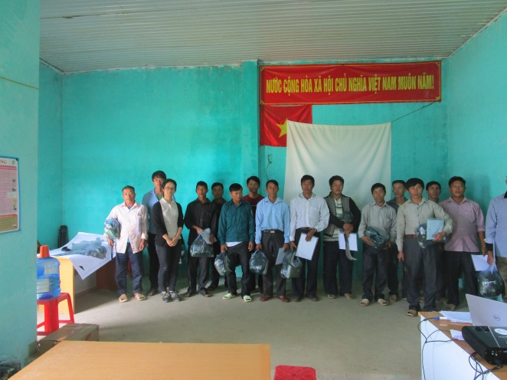  Image 3: Provision of forest patrolling tools to VFPT members | 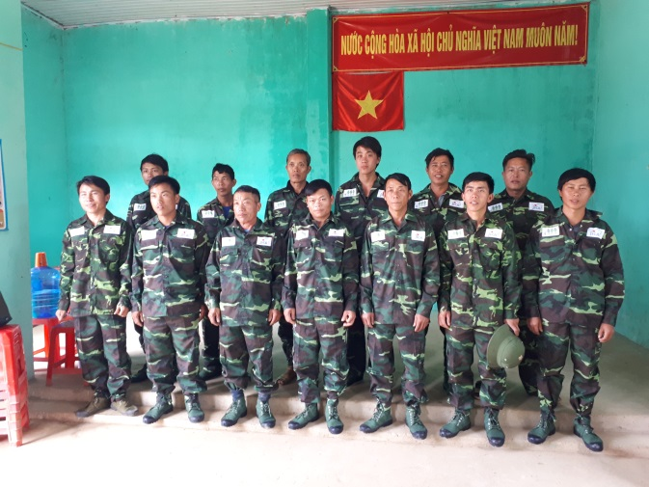  Image 4: Provision of uniform to VFPT members
According to experience of VFPTs, binoculars is very helpful to observe certain parts of special use forest where are inaccessible.
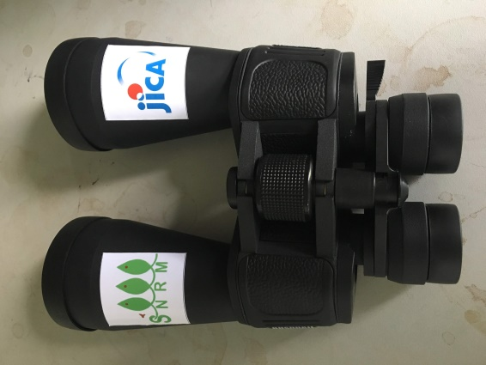 | 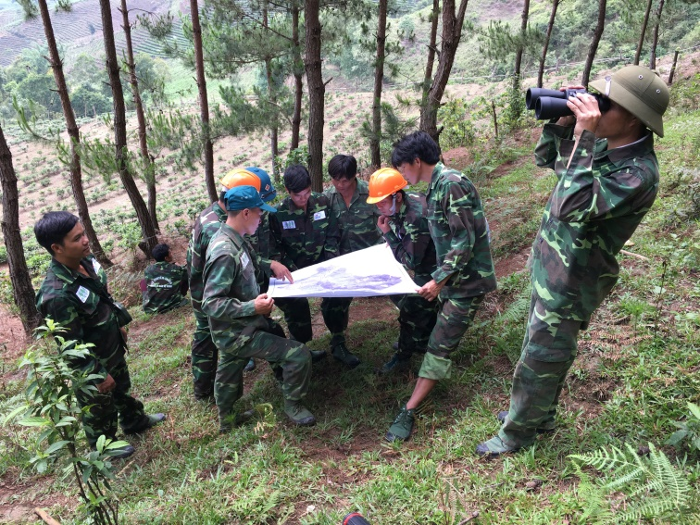
Image 5: Supported binoculars | Image 6: VFPT members use supported tools

Besides, the Project also provided each VFPT with a clear satellite forest patrol route map, indicating the way to patrol, which is very useful for all members, particularly for the new ones or who are not familiar with forest path. This route map was well prepared from results of a Project survey on forest and then discussed and verified with groups of villagers who know the forest very well. Furthermore, the patrol route map also indicates forest area that each village in charge of protecting.
The forest patrol route map is supposed to be taken with a group of VFPT members when patrolling and stored and protected in a storage tube provided by the Project. The map not only indicates the patrol route but also helps VFPT members note location such as landmarks and other information such as plot number if there are any changes in forest.
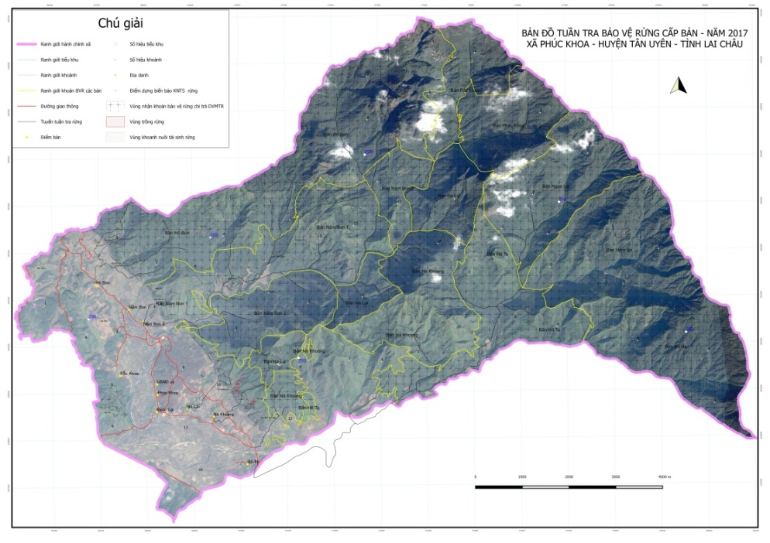 | 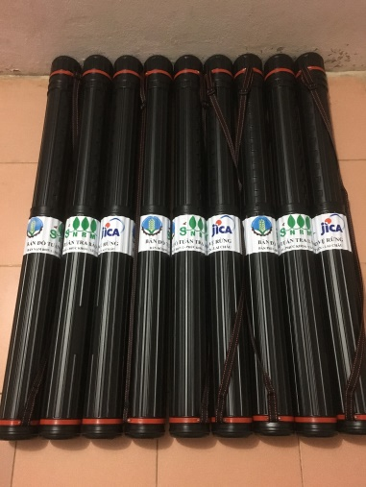
Image 7: Forest patrol route map | Image 8: Storage tube for map

USE OF PAYMENT FOR FOREST ENVIRONMENTAL SERVICES (PFES) IN FOREST MANAGEMENT
In Lai Chau, PFES has been introduced since 2012 aiming to incentivize individuals and communities to sustainably manage and protect their forests by providing compensation for their efforts. PFES fund accounts for 100% of the fund allocated to forest protection, suggesting the significant role of PFES in forest protection.
The utilization of PFES were discussed regarding village authority with forest regulations, as well as the forest management and livelihood development practices supported by SNRM. The status and allocation of PFES qualified forests, and the revenue and expenditure of village fund incorporating PFES in SNRM target villages were analyzed.
It showed that PFES deduction amount was always a controversial issue between CPC and villages in recent years, ranging from 10% - 12% of the total PFES fund. Recently, the agreement was that each village deducted 10% of the total PFES amount, although based on Degree 36 issued in 2014 by Lai Chau Provincial People’s Committee (PPC); it should be 30%.
In Phuc Khoa CPC, the total PFES fund is first deducted 10% for village fund and the rest is equally divided to households. The deducted amount (10%), as village fund, from PFES is allowed to spend for the following six categories.
- Support forest patrolling and protection
- Purchase of tools and equipment for forest management and protection, fire prevention and fighting
- Clearance and maintenance of fire break lines
- Support the work at forest entrance
- Repair of village community construction (culture house, classes, bridge, roads, irrigation work…)
- Support purchase of production inputs, seeds for agroforestry development
Table 3: Scenario of optimum PFES utilization in forest protection in villages
No. | Village | Protected Forest area protected in 2018 (ha) | Amount of 10% deducted from PFES in 2018 (VND) | No. of patrolling time/year | No. of patrolling time/month/group of 4 members
 |  |  |  |  | Rainy season | Dry season
1 | Hô Bon | 1,047.23 | 135,721,008 | 226 | 1 | 28
2 | Nà Lại | 342.36 | 44,369,856 | 74 | 1 | 9
3 | Pắc Khoa | 203.32 | 26,350,272 | 44 | 1 | 5
4 | Nậm Bon 1 | 394.65 | 51,146,640 | 85 | 1 | 10
5 | Nậm Bon 2 | 471.17 | 61,063,632 | 102 | 1 | 12
6 | Nà Khoang | 400.15 | 51,859,440 | 86 | 1 | 10
7 | Phúc Khoa | 329.70 | 42,729,120 | 71 | 1 | 8
8 | Hô Ta | 456.95 | 59,220,720 | 99 | 1 | 12
9 | Ngọc Lại | 521.59 | 67,598,064 | 113 | 1 | 14
The SNRM Project planned a scenario for VFPTs in which all FPES deducted amount would be totally used for forest protection in term of patrolling; if so, how many time a year and a month that a VFPT can go on patrol (Table 3). Assuming 1 time a month patrolling during rainy season based on the VPFT regulations, it resulted in a big range, from 5 times to 28 times a month patrolling, depending on forest area of each village. This assumption is prepared for a group of 4 members and payment of VND 150,000 per time.
This scenario is very important and helpful for VFPTs in order to overview and therefore prepare patrolling plan. Moreover, VFPTs also understand this is maximum number of time patrolling and if village fund would allocate in other categories, the number of time patrolling a month would become less.
However, in reality, it is quite common to see in villages that the PFES deducted fund is not only spending for forest protection and development but also for other categories. The problem is that PFES is the only income source of village fund.

ACTUAL PATROLLING IN VILLAGES
Remarkably, regular patrolling in villages was only conducted in recent years and after the SNRM Project implementation. This is absolutely a big change and good improvement. Before the Project time, VFPT members were totally not clear with general information of their forest protection area and even had no idea of forest location and satellite image map.
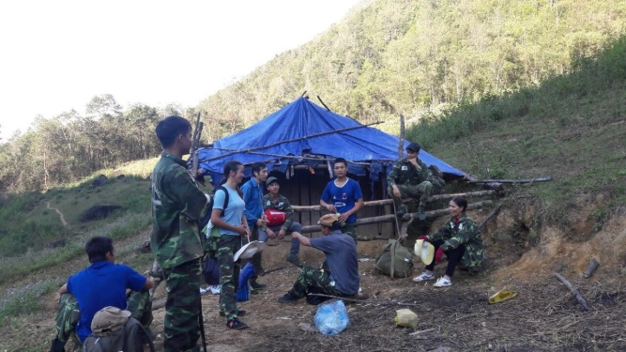 | 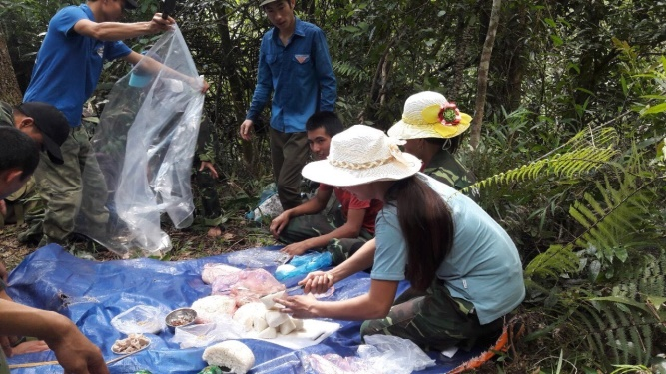
Image 9: Making a camp in forest while patrolling | Image 10: Having lunch and dinner while patrolling
Since VFPTs are consolidated and supported by the SNRP Project, patrolling has been started in the villages. VFPTs often organized, only first time, patrolling so that all members went on patrol; this is important to make sure everybody understands, gets to be familiar the way and helps each other. From second time on, it was recommended to patrol with a small group of four or five members depending on the distance to the protected area.
VFPT member’s allowance for patrolling is paid equally from deducted PFES, depending on number of times he or she went on patrol. There was no official instruction from local authorities for this payment, but it could be different from VPFT to VFPT. However, how to pay or the payment amount was deeply discussed within VPFTs, that was, not too much and not too low, considering labor market situation and responsibility. Furthermore, VPFTs got reference from other VFPTs. In 2017 and 2018, the paid were 150,000 and 200,000 VND, respectively, per person per time.
According to VFPTs, this payment amount is rather reasonable. VFPT heads recorded the patrolling assignment and actual work of each member during the year; at the end of the year when PFES is paid and available, VFPT’s members would receive their allowance based on actual work. As stated by VFPT members, the allowance is rather fair to everybody, both in terms of contribution, meaning “no work, no pay”, and amount.
Actual patrolling was conducted out in all villages, average from one to two times a month per VFPT in dry season (from September this year to April next year). In reality, VFPTs did not go on patrol during rainy months, from May to August; this is due to the difficult geographic condition and less risk of forest fire and logging. As shown in Table 3, obviously to see that the number of actual patrolling is rather little compared with the scenario in which all deducted fund is only spent for patrolling. Nevertheless, the fund is also allowed to other five categories.
VFPT members had a chance to observe their protected areas. Despite patrolling as a regular task, many VFPT members reported they had seen their protection area for the first time. For this evidence, the SNRM Project has played an important supporter making the VFPTs work out.
When patrolling, VFPTs are facing with some difficulties including a long distance and no existing paths. For some forest areas nearby Lao Cai Province, it often takes the whole day walking for one way; this means it takes three days for one patrolling. Or one needs to start walking very early in the morning today so as to be back home late the following day if planning for two days. Staying overnight must be prepared. On the top of that, many parts, deep in the forest, have no path existing, but only bushes or rock; it also takes time to walk.
To stay overnight, each member needs to prepare personal stuff such as food and tools; all seems to be challenging for VFPT members for patrolling.

MONITORING
The monitoring process which is applicable to the trained and tool-equipped VFPT members has shown clear positive results.
Table 04: Synthesis of monitoring indicators applicable for forest protection
No. | Monitoring indicators | Quantity
1 | Forest area protected by the FPTs | 4,230.51 ha
2 | Forest patrolling routes | 12 routes
3 | Forest patrolling plans | 9 villages
4 | Frequency of forest patrolling | 1 time/month during rainy season and regular during dry season
5 | Allowances for FPT members | 150,000-200,000 VND/time/group of 4 members
6 | Number of violations | 4

Since VFPTs started getting the Project’s support in 2017, as of March 2020, there were four illegal cases found by VFPTs; of those, two cases related to forest fires, one related to the extension of tea gardens into forest land, and one logging case. These cases were reported to Commune Forest Rangers for further actions. Commune Forest Rangers later have collaborated with relevant local agencies such as CPC, police, village management boards to handle these detected cases.

LESSONS LEARNT
The SNRM Project wishes to focus on sustainable forest protection particularly in terms of keeping regular forest patrolling activity in villages. As such, the following key points were identified for further development.
- The fact shows that special use forest in Phuc Khoa Commune has extremely difficult geographical conditions; thus, it is big challenges for VFTPs in patrolling through the protected forest areas. There might have no existing path in forest and it often took several days to go on patrol per time, suggesting an important role of selection of active VFPT members
- According to the instruction of Decision number 36/2014/QD-UBND, issued on September 2014 of Lai Chau Provincial People Committee, PFES fund, namely village fund, should be reinvested in direct forest protection and spent in other categories relating to forest protection and development such as purchase of patrolling equipment/tools. However, it revealed that the village fund was sometimes mobilized for other purposes which were unrelated to forest protection and management such as installing road light in the village. Thus, the number of patrolling time would be definitely reduced.
- To go on patrol, division of a VFPT into small groups, consisting of 4-5 members, seems to be more effective in terms of collaboration and incentive saving. Moreover, in any group, there must be someone who can read and write in order to prepare a report and access to information on the map
- Incentive to VFPT members for patrolling was a controversial issue; this should be carefully discussed and agreed among all members. Little payment would not be able to encourage members to do the job while paying too much would negatively affect the PFES fund and might get criticism from other villagers. Consequently, actual fee for patrolling has been determined both prevailing wage in the area as well as a level of responsible positions in the community.
- A patrolling work plan for a new month needs to be well prepared ahead, often by the end of the month; however, it should be a bit flexible or be able to change according to certain circumstances like unexpected events, sickness and so on. T
- Tools and equipment play an important role in stimulating VFPT member spirits and be helpful while patrolling. This indicates all new members are well equipped and old members can also be supplemented tools and equipment if they are worn-out or broken
- In comparison to others, some VFPTs do not actively take responsibility of preparing patrolling plan as well as implementing patrolling activity according to forest regulations. Regular checking and monitoring by relevant agencies such as CPC, CFRs would greatly encourage and facilitate the work
- As the role of a VFPT leader is greatly important in managing and monitoring the whole team; he/she should have a good capacity of management, leadership and power. Therefore, village leader is the most appropriate person to be VFPT leader
- Before the SNRM Project implementation, VFPTs were not professionally organized and operated, and VFPT members were totally unfamiliar with basic information on forest and techniques when patrolling; consequently, patrolling task was not conducted properly

RECOMMENDATIONS
Based upon the VFPT performance, the following recommendations are made for VFPT improvement in Phuc Khoa.
- As patrolling is not likely to be completed within one day but often about two or three days per time and requires an overnight stay in forest; thus, it needs to prepare a tent for each VFPT’s protection forest area. These temporary tents for patrolling groups are better to be prepared by environmental friendly and locally available materials.
- VFPT members are reviewed and reselected yearly and new persons may join in; therefore, it is necessary to build capacity for VFPTs; more specifically, to organize new technical training courses for new ones and refresh training for old members. Importantly, these two training courses, for new and old members, should not be separated but be combined in order the old members could share experiences and they can learn from each other
- Phuc Khoa CPC should continue to advise villages for proper use of village fund; village fund which is mainly contributed by the PFES fund should be allocate to forest protection including patrolling fee and necessary tools and equipment and so on. Additionally, the amount of PFES fund deducted to village fund should be widely discussed and agreed together with villages in order to ensure that the fund can cover all expenses for forest protection
- CFRs should regularly communicate with VFPTs to update forest status and provide advice or any support if necessary. As planned, CFRs and VFPTs should keep monthly meetings to review and prepare work plan and reporting
- VFPTs should spend more time and efforts patrolling and focusing on certain forest areas where illegal forest encroachment and fire often happens. Frequently, CFRs and VFPTs also need to identify those forest areas
- As mentioned previously, it is important to marshal, consolidate and motivate active VFPT members; thus, it would be worth to offer reasonable incentives, rewards for good performance and recognition by CPC and CFRs for increasing retention. There are many ways of rewards; for example, a small amount of money and perfect-performance certificates, are given to VFPTs and its members
- Necessary tools and equipment should be provided periodically to stimulate VFPT members’ spirits and work more effectively. In addition, satellite maps also need to be updated, if any, and delivered; this absolutely requires external support, for instance, from District FRs, or District Protection Forest Management Board
- As CPC organizes monthly meeting where all VFPT leaders gathered, this is also the best time for reporting forest status as well as patrolling activity in the month

