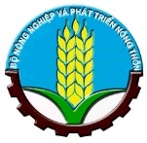 | 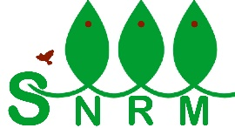 | 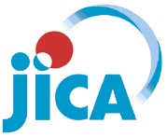

Japan International Cooperation Agency (JICA)
Sustainable Natural Resource Management Project (SNRM)

CASE STUDY

BEEKEEPING WITH LOCAL HONEYBEE SPECIES
USING MODERN TECHNIQUES
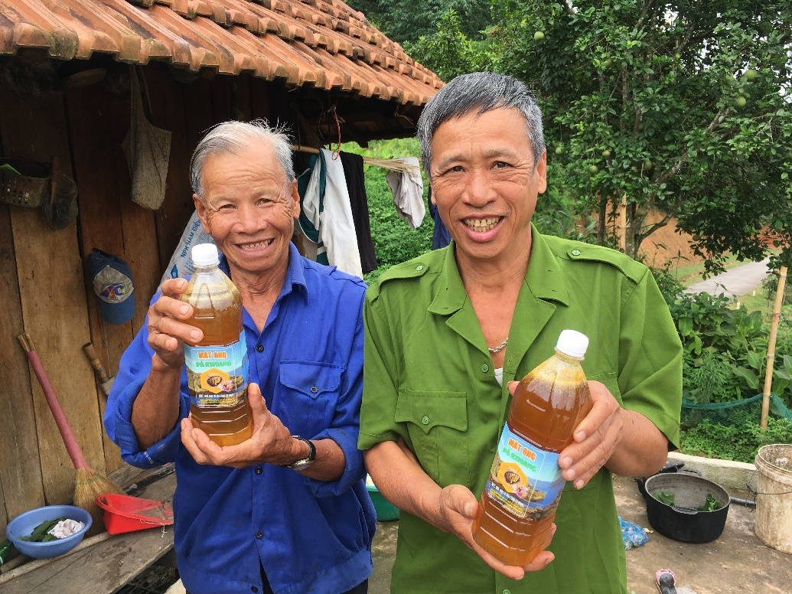

Nghiem Xuan Hung – Project technical officer

August 2020

This report was prepared as a part of the Sustainable Natural Resource Management Project (SNRM) funded by the Japan International Cooperation Agency (JICA) and executed by the Ministry of Agriculture and Rural Development of Viet Nam from 2015 to 2020.

The views expressed in this report are those of the authors and do not necessarily reflect the view of SNRM or JICA.

JICA/SNRM encourages reproduction and dissemination of material in this report. Non-commercial uses will be authorized free of charge upon request. Reproduction for commercial purposes, please contact JICA/SNRM for a prior and specific agreement.

All queries should be addressed to:

Officer in Charge of Forestry Projects/Programmes
JICA Viet Nam Office
11F CornerStone Building, 16 Phan Chu Trinh, Hoan Kiem, Ha Noi, Viet Nam
Tel: +84-4-3831-5005
Fax: + 84-4-3831-5009

Table of Contents

I. Background and Objectives 1
II. Scope of project’s support 1
III. Project’s support policy 2
IV. Achievements 3
4.1 Technical impacts 4
4.2 Economic impacts 4
4.3 Social impacts 4
4.4 Environmental impacts 4
V. Lesson learnt 5
5.1 Selection of beekeepers 5
5.2 Marketing 5

List of Abbreviations

CPC | Commune people’s committee
JICA | Japan International Cooperation Agency
OCOP | One Commune One Product
REDD+ | Reducing emissions from deforestation and forest degradation and the role of conservation, sustainable management of forests and enhancement of forest carbon stocks in developing countries
SNRM | Sustainable Natural Resource Management Project
VND | Vietnamese dong

I. Background and Objectives
Pa Khoang is a mountainous commune located in the northeast of Dien Bien Phu City, Dien Bien Province, which is one of four selected communes to implement pilot activities on REDD+ under the Sustainable Natural Resources Management project (SNRM). The objective of the project is to promote sustainable natural resource management to bring benefits to the people through the implementation of forest protection and development plans.
The project duration is from August 2015 to August 2020, focusing on forest management and development support activities such as forest regeneration, af/reforestation, scattered tree planting, establishment of forest patrolling teams, and Village Forest Management Regulations formulation. In addition, the project also supports a number of activities on livelihood improvement, including beekeeping with a technique transferring local honeybee colonies from traditional beehives to modern ones.
Beekeeping with western honeybee species using modern beehives (square box type) has been applied with high economic efficiency even in Dien Bien Province. In Pa Khoang Commune, wild honey produced by local honeybee species is one of valuable non-timber forest products, bringing good income to the local people. Honey used to be exploited directly from the forests or from traditional beehives (round shape beehives made of hollow woody stems, 60-80cm long, both sides covered with timber with small openings for bees coming and going). However, the traditional way of harvesting honey by the local people is destructive as they harvest not only honey but also honeycombs with bee eggs, larvae and pupae. Therefore, beekeepers used to encounter cases of evading of bees without return after harvesting honey, and the time between honey harvesting times was rather long as the bees have to build combs again, affecting the quantity of honey harvested.
Transferring honeybee colonies from traditional beehives to modern ones helps local beekeepers take care of and manage bees in a sustainable way, increasing productivity and thereby increasing income and improving their livelihoods. Besides, the initiative of the advanced beekeeping can limit people to go to the forests to gather wild honey, thereby mitigate the risk of forest fires, and contribute to protect and manage the forests in a sustainable way.

II. Scope of project’s support
The target of the project’s support was those households who were using traditional style beehives and wished to participate in the activity. The project selected 3 villages (Vang 1, Pa Tra and Dong Met 1) and 10 households per village were provided with technical support during the first year (2017). In 2019, based on the performance of the first 3 villages, the project expanded its support to 10 more households in 5 villages (Co Cuom, Bo, Ha 1 and 2, and Xom 2).
The project has mainly provided technical support to the beekeepers to transfer honeybee colonies from existing traditional beehives to modern ones. An expert on beekeeping from the Northern College of Agriculture and Rural Development was recruited to train the local beekeepers with techniques of rearing, caring and managing bees. The project also employed a beekeeping specialist from Dien Bien Province to directly support the transfer of honeybee colonies of the local beekeepers.
The project supported the transfer with 130 beehives for 40 households (3-4 beehives/ household); some materials/tools for beekeeping such as smoke sprayers, beekeeping veils/hats, screw cutting knives, honey extractors, bee wax foundation sheets, and bottles for containing honey, etc.

III. Project’s support policy
The transfer of honeybee colonies is based on voluntary participation of the local households. The participating households were required to sign on a commitment agreement to comply with the technical processes of beekeeping guided by the project, pledge to strictly implement the Village Forest Management Regulations and fully participate in village forest protection and management activities.

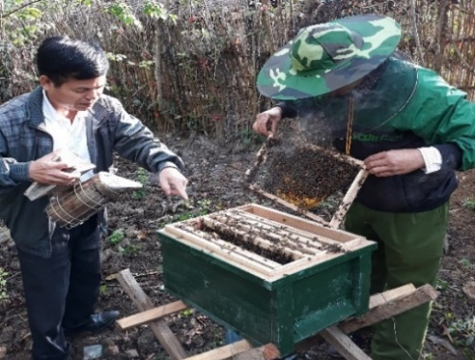
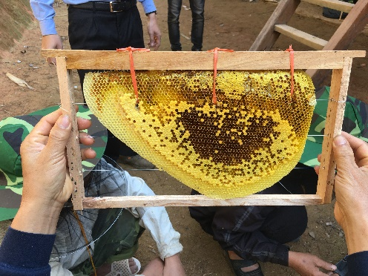
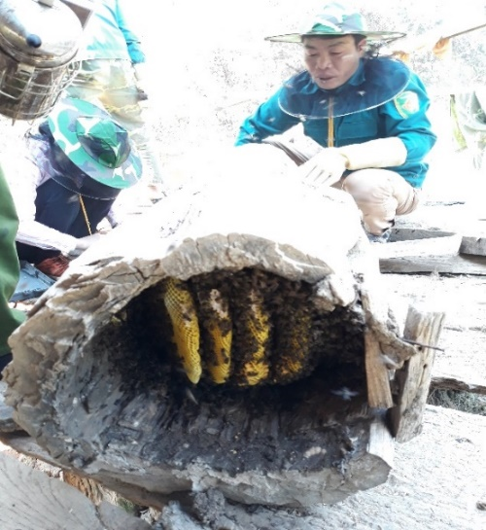
Traditional beehive
Transfer honeycomb from traditional beehive to modern one
Check bees after 5 days of transfer

IV. Achievements
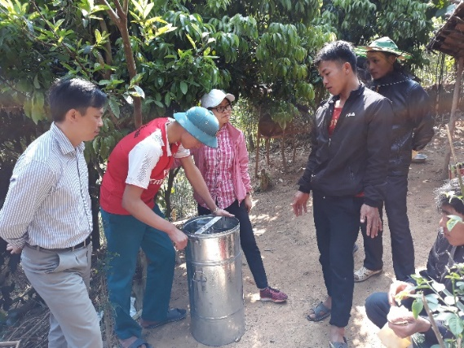
The SNRM Monitoring results revealed that, besides the supported beehives, the participants developed 19 beehives by themselves in 2019 and 73 in 2020. The participants transferred 71 bee colonies to modern beehives in 2019 and 98 in 2020. The number of transfer depends on existing bee colonies at the time of transferring. In 2019, 40 interviewed beekeepers shared that they harvested 672 liters of honey, and sold 662 liters. In 2020, 35 households harvested 353 liters and sold 325 liters. This significant reduction in 2020 compared with the one of 2019 was caused by the reason that the rainy season came earlier so honey harvesting period was shorter than the previous year.
Guidance on how to use honey extractor
The project supported the beekeepers in establishing own brand of the honey “Pa Khoang Honey”, and designing and printing honey bottle labels. In addition, signboards for promoting honey sales were installed in Vang 1, Pa Tra, and Dong Met 1 Villages. Lists of potential customers were also prepared with supports from the project so that each participant can easily access to the market.
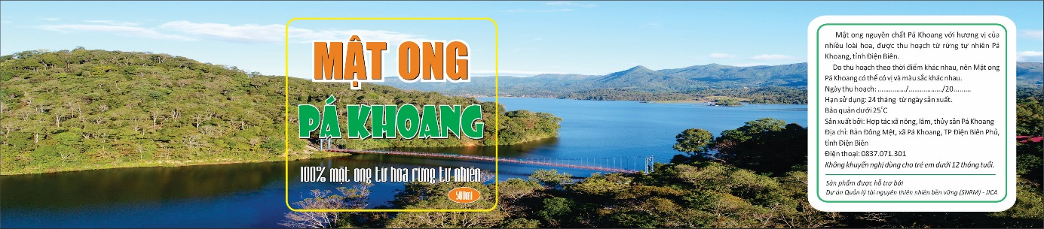
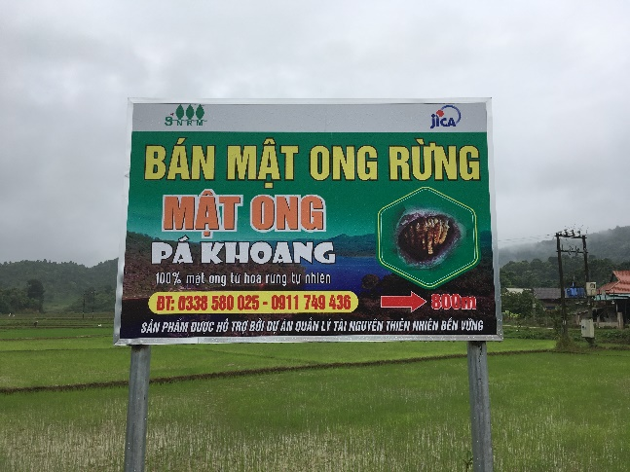
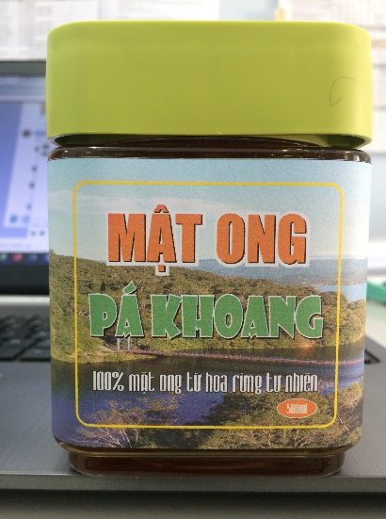
Signboard for sales promotion
Labelled honey bottle

To further support the beekeepers in honey marketing, the project consulted the provincial Sub-department of Quality Management of Agro-Forestry-Fisheries Products, also collaborated with the Pa Khoang Agriculture, Forestry and Fisheries Co-operative as well as the Pa Khoang Commune People’s Committee (CPC). As the results of required processes, a Certificate of Compliance with Food Safety Regulations (right photo) for the honey was given to the co-operative by the Sub-department in June 2020. It is expected that this will encourage the beekeepers to market their honey with higher price. This certificate is also the first step for the CPC to register the honey with the One Commune One Product (OCOP) initiatives.
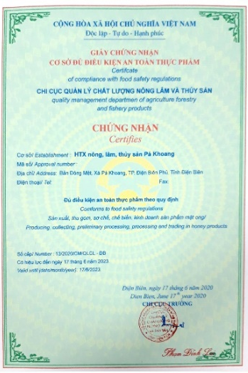
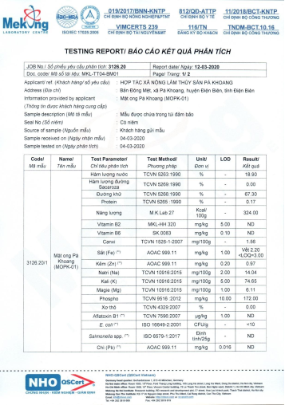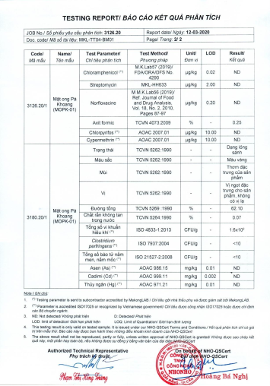
The aspects regarded as impacts of the supports by the project are summarized as below:
Pa Khoang honey quality test and Certificate of food safety

4.1 Technical impacts
The 40 beekeepers have been trained by the project regarding the advanced beekeeping techniques using modern beehives. They also learned about basic beekeeping knowledge and techniques including how to avoid evading of bee colonies, splitting of bee colonies, feeding during rainy season when less flowers are available, and treatment of common diseases. All these knowledge and techniques help the beekeepers maintain and breed honeybees. Honey harvesting increased to 5-6 times per year, while just twice per year with the traditional beekeeping method.
The project also delivered training on honey harvesting with an extractor and post harvesting techniques such as packaging for preservation and sales as stated earlier.

4.2 Economic impacts
The quantity of harvested honey from the modern or advanced beekeeping model is estimated at around 7-18 litters/beehive/year (with 5 frames for beeswax foundation), with a selling price of VND 170,000 – 200,000/litter (average 185,000/litter), income for the beekeepers is from 1.2 to 3.6 million/beehive. Mr. Quang Van Hung in Vang 1 Village kept 3 beehives and harvested 60 litters of honey equivalent to VND 11 million of income in 2019 (from February to June), while the other households who followed traditional beekeeping model earned just about VND 0.7 - 1.5 million/beehive/year (subject to large or small beehives). Thus, the beekeepers’ income has increased from 1.7 to 2.4 times/beehive compared to the traditional practice of beekeeping.

4.3 Social impacts
The project has initially assisted the participants to develop the advanced beekeeping model for sustainable bee keeping. The participating beekeepers established 4 interest groups to help each other and share techniques and experiences. The project helped the local people exploit potential and take full advantage of the local resources to increase income, reduce poverty, and improve rural livelihoods.

4.4 Environmental impacts
The beekeepers not only received technical training on the advanced beekeeping techniques but also better understood the roles and importance of forests to their livelihoods. By signing on the commitments to implement the Village Forest Management Regulations, af/reforestation, forests regeneration, and forest patrolling, the local people better understand the roles of forests in protecting and regulating water sources for production and daily life, and providing valuable forest products such as mushrooms, bamboo shoots, honey, medicinal plants. It is expected that they will further contribute to forest protection and development in a sustainable way.

V. Lesson learnt

5.1 Selection of beekeepers
Beekeeping is a both easy and difficult practice. It is difficult for those who do not want to invest in technology application, but easy for those who are interested in, and want to learn hardly and stick with it for a long time. Therefore, selecting right beekeepers to be supported by the project is very important. In addition, for the project area, the local people stay in the area where their houses are located during agricultural cropping season but they go for work far away from home during the rest of the time. Therefore, it is necessary to consider carefully who should be selected to be the target of the project for beekeeping.

5.2 Marketing
Marketing is an extremely important activity to promote sales of honey. In general, local beekeepers do not have knowledge and skills to market their products. Therefore, supporting the local beekeepers in marketing and creating new sales channels of honey leads to success in beekeeping with the modern techniques.
Meanwhile, poor quality honey or fake honey can easily be found in the market, which affects buying decision of customers. The consumers do not trust enough on the products or only willing to pay very low price. Accordingly, certification of products such as food security should be considered as a significant tool to add more value on the products.

He is one of the 13 good model beekeepers in the 3 villages where 30 households applied new techniques of beekeeping.

