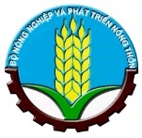 | 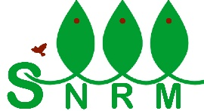 | 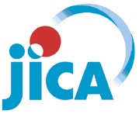

Japan International Cooperation Agency (JICA)
Sustainable Natural Resource Management Project (SNRM)

CASE STUDY

EXTENSION OF IMPROVED COOKSTOVE
IN PA KHOANG COMMUNE, DIEN BIEN PHU CITY,
DIEN BIEN PROVINCE

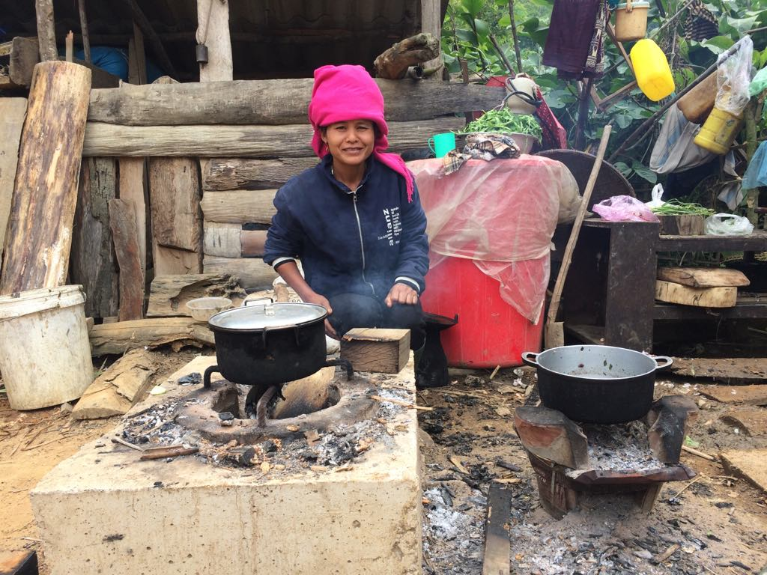

Mac Van Vung – Project Coordinator in Dien Bien Province

August 2020

This report was prepared as a part of the Sustainable Natural Resource Management Project (SNRM) funded by the Japan International Cooperation Agency (JICA) and executed by the Ministry of Agriculture and Rural Development of Viet Nam from 2015 to 2020.

The views expressed in this report are those of the authors and do not necessarily reflect the view of SNRM or JICA.

JICA/SNRM encourages reproduction and dissemination of material in this report. Non-commercial uses will be authorized free of charge upon request. Reproduction for commercial purposes, please contact JICA/SNRM for a prior and specific agreement.

All queries should be addressed to:

Officer in Charge of Forestry Projects/Programmes
JICA Viet Nam Office
11F CornerStone Building, 16 Phan Chu Trinh, Hoan Kiem, Ha Noi, Viet Nam
Tel: +84-4-3831-5005
Fax: + 84-4-3831-5009

Contents

I. Background and Objectives 1
II. Scope of project’s support and villagers’ contribution 1
III. Achievements 2
IV. Impacts 3
4.1 Economic impacts 3
4.2 Social impacts 3
4.3 Environmental impacts 4
V. Conclusion 4

List of Abbreviations

CPC | Commune people’s committee
HH(s) | Household(s)
JICA | Japan International Cooperation Agency
REDD+ | Reducing emissions from deforestation and forest degradation and the role of conservation, sustainable management of forests and enhancement of forest carbon stocks in developing countries
SNRM | Sustainable Natural Resource Management Project
SUSFORM-NOW | Project for Sustainable Forest Management in the Northwest Watershed Area
VND | Vietnamese Dong

I. Background and Objectives
Pa Khoang is a mountainous commune located in the northeast of Dien Bien Phu City, Dien Bien Province, which is one of four selected communes to implement pilot activities on the REDD + under the Sustainable Natural Resources Management Project (SNRM). The objective of the project is to promote sustainable natural resource management to bring benefits to the people through the implementation of Forest Protection and Development plans.
The project duration is from August 2015 to August 2020, focusing on forest management and development support activities such as forest regeneration, af/reforestation, scattered tree planting, establishment of forest patrolling teams, and village forest protection charter formulation. In addition, the project also supports villagers in some livelihood development activities for improving their economic condition so as to reduce pressure on the forests in the area. Extension of the improved cookstove is one of those activities.
In Dien Bien Province, based on the achievement of the ‘Project for Sustainable Forest Management in the Northwest Watershed Area (SUSFORM-NOW)’, the project applied the model of Lao cookstove to the villagers. In 2017 and 2018, the project supported 198 Lao cookstoves to 189 households (HHs) (270 cookstoves for 262 HHs in December 2017 and 126 for 115 HHs in June 2018). The Lao cookstoves already contributed much on saving time for firewood collection and for cooking of the participated HHs, and especially reducing pressure on the forests because the villagers do not need to collect much firewood than before. Based on the monitoring results, the activity participants shared that they could save 1/3 firewood thanks to the introduction of the cookstoves. On the other hand, the constraints of Lao cookstove are found that it is rather small so it can only be used for cooking with small pans or pots, the villagers have to cut firewood into small pieces, and the part where firewood is placed is easily broken. Again it is difficult for the villagers to purchase Lao cookstoves because they are ordered from Lao but not available at markets in Dien Bien. Those are considered as the major reasons why this model of cookstoves could not have been expanded in the area.
With the same purposes of the project activities in Son La and Lai Chau provinces, the project developed a model of another type of improved cookstove which is made of cement, gravels, sand and iron bars. This type of cookstove is solid and strong enough, the villagers can cook with bigger pans or pots, and they don’t have to cut firewood into small pieces. The project staff in Dien Bien Province leant from experiences in Lai Chau Province, collected 3 sets of cookstove frames and expanded this improved cookstove model to HHs in Pa Khoang Commune of Dien Bien Phu City.

II. Scope of project’s support and villagers’ contribution
As the same as the other livelihood activities of the project, the villagers were requested to contribute some amount to the village fund as well as labor to produce cookstoves if they wish to participate in the activity. Since this was a new cookstove model to the commune and the resources (frames) were limited, the project could not conduct this activity in the whole commune but in selected villages where the village heads and villagers were ready to apply the new model. At the beginning, 3 villages were selected for initiating this type of cookstove; Dong Met 2, Xom 2 and Nghiu 2. At a later time, village heads in other villages learnt the new cookstove model and requested the project for support. Those 5 villages were selected for the second round of support, including Bo, Xom 1, Xom 3, Ha 2, Vang 1 villages. The project could only support 90 cookstoves in total according to the budgetary conditions.
The project provided iron bars and cement, and the participants contributed sand, gravels and labor for making improved cookstoves. Moreover, all the participants were also required to contribute 1/3 of the production cost equivalent to 100,000 VND to the village funds before initiating the activity.

III. Achievements
Besides the support for materials, the project provided technical support on making improved cookstoves. In each village, the project staff demonstrated to the participants how to produce the cookstove. Since the techniques for making that type of improved cookstoves are not so complicated, the participants could produce by themselves with the materials which were supported by the project and their own contribution.
The cookstove frames were transferred among the participated HHs for making cookstoves. As a result, 90 selected HHs already made the cookstoves and enjoy using them for daily cooking thanks to the support of the project on materials and techniques as well as their contribution.
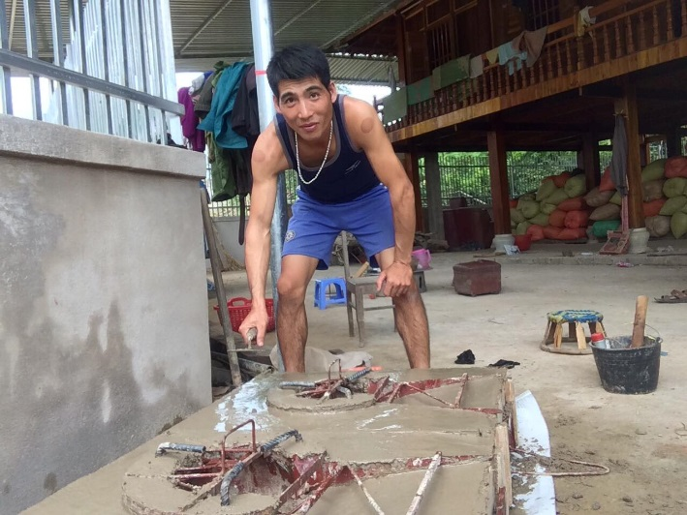
Picture 1: Producing improved cookstove by villager

After some time of the daily use of the cookstove, neighbors of the selected HHs, who were non-participants in the activity, really liked the new improved cookstove model. Therefore, they leant how to make the cookstove from the selected HHs, prepared materials and made cookstoves by their own efforts. Based on the monitoring results of May 2020, besides the 90 HHs supported by the project, it was confirmed that another 145 HHs already made cookstoves without support from the project (Table 1), which indicates more than one third of the HHs of the target villages for this activity enjoy this type of cookstoves now. The cookstove frames are still being transferred among the HHs in Pa Khoang Commune for continual production of the improved cookstoves.
The reasons why the villagers prefer the new type of improved cookstove than Lao cookstove are mainly explained by them that the cookstove allow them to use various sizes of pans or pots (from small to big), use large firewood (no need to cut firewood into small pieces), save firewood, reduce labor for collecting firewood and contribute to forest protection.
Table 1. Number of households that produced improved cookstoves
No | Village | Total no.  of HHs | No. of HHs with improved cookstoves
 |  |  | with project support | without project support | Total
1 | Vang 1 | 42 | 4 | 1 | 5
2 | Vang 2 | 50 | 0 | 1 | 1
3 | Dong Met 2 | 73 | 15 | 8 | 23
4 | Xom 1 | 54 | 9 | 15 | 24
5 | Xom 2 | 66 | 15 | 1 | 16
6 | Xom 3 | 60 | 10 | 3 | 13
7 | Ten | 39 | 0 | 1 | 1
8 | Nghiu 1 | 59 | 8 | 35 | 43
9 | Nghiu 2 | 46 | 8 | 49 | 57
10 | Ha 2 | 34 | 6 | 30 | 36
11 | Bo | 35 | 5 | 0 | 5
12 | Co Cuom | 57 | 0 | 1 | 1
13 | Sang | 28 | 10 | 0 | 10
Total |  | 643 | 90 | 145 | 235
Source: Monitoring data in May 2020
Note: Some HHs made more than one cookstove, thus the total number of cookstoves of some villages comes more than the number of the total HHs.

IV. Impacts

4.1 Economic impacts
In Pa Khoang Commune, nearly all the HHs rely on firewood for cooking. They also use firewood for drying agricultural products and keeping themselves warm in cold seasons. They collect firewood mainly from natural forests. According to an estimation of the villagers during the monitoring, each HH can consume 6 m³ of firewood for cooking a year. This indicates that the villagers have to spend much time and labor for collecting firewood. Currently 235 out of nearly 1,000 HHs of 21 villages in Pa Khoang Commune use the new type of improved cookstoves for their needs. The improved cookstoves can save at least one third of the amount of firewood so far consumed by traditional cookstoves, making the villagers use the spare time for doing other business.
Another economic advantage of this type of cookstoves relates to the village fund. The participants with the support by the project on making improved cookstoves had to contribute 100,000 VND to the village funds so the other HHs can access to the fund by borrowing money for investment to their family business. Thanks to this support, it is expected that the villagers in Pa Khoang Commune can improve their household economic status and uplift their living standards.

4.2 Social impacts
Making improved cookstove does not require very high level of techniques, but making high quality (also nice looking) cookstoves is not so easy. The project staff only introduced the techniques of making cookstove once per village, followed by production by the villagers’ own efforts. In 5 villages (Nghiu 1, Nghiu 2, Sang, Xom 2, Dong Met 2), there are some men who can produce high quality cookstoves and they extended voluntary support to other HHs. The cookstove frames were not only used in the selected villages but in the other villagers. At least in 3 villages (Co Cuom, Ten, Vang 2), where the project didn’t introduce this type of cookstoves (Table 1), borrowed the frames and produced their own cookstoves. The villagers encourage each other on making cookstoves for saving firewood and labor, making the relationship among the villagers inside one village and with other villages strengthened.

4.3 Environmental impacts
The villagers who had the new model of improved cookstove could already have reduced consumption of around 30 to 40% of firewood. This obviously help reduce pressure on forests as well as smoke pollution in their houses. As stated earlier, each household is estimated to use 6 m³ of firewood for daily life yearly. Thus, reduction of 30%-40% of firewood consumption can contribute huge impact to the environment in the commune.
It is also significant to mention that the participants have also enhanced their understanding on the roles and importance of forests to their livelihoods. They can now recognize that using the improved cookstoves contributes to improve forest conditions by not cutting many trees for firewood. The local people better understand the roles of forests in protecting and regulating water sources for production and daily life, providing valuable forest products such as mushroom, bamboo shoots, honey, medicinal plants and so forth. They then will contribute to forest protection and development in a sustainable way.

V. Conclusion
One of the factors in the successful extension of the new type of cookstove is that the cookstove matched the needs of the local population as already stated. Meanwhile, another factor can be considered to be the approach that the project took. The project selected 3 villages whose village leaders are rather enthusiastic about the new cookstove because the number of the frames was quite limited, and provided the support for developing a model of the new type of the cookstoves. It is noteworthy that the project applied a partial co-payment system that the beneficiaries were required to pay 100,000 VND and afford other materials such as sand, gravels and labour by themselves. It is believed this contributed to the autogenous expansion of the new cookstoves to many HHs in the villages.
However, one question can be raised why the significant autogenous expansion of the new cookstoves took place just in the 2 villages (Nghiu 1 and Nghiu 2). The probable reason relates to availability of firewood. The 2 villages have just a small forest area of the Special Use Forest with relatively large population. Thus, the villagers are facing difficulty in collecting firewood from the forests. In contrast, amongst other villages, Bo Village owns a large area of the Production Forest where the villagers can freely collect firewood, whist the residents of Sang village also enjoy easy firewood collection since the village is very small (just 28 HHs) and is located in a remote area to which the other villagers cannot access.
Since the spontaneous production of the improved cookstove still continues in some villages, the number of beneficiary HHs should regularly be monitored and a causal relation between the spontaneous expansion of the cookstove and availability of firewood is expected to be further examined.

